Press release

Trendsetting architecture in the limelight
Zumtobel illuminates new showcase project by architect Dietmar Eberle

The renowned, internationally active architect Dietmar Eberle has created a stir with an extraordinary office building in Lustenau, Vorarlberg. The radical energy concept includes neither heating nor ventilation systems but nevertheless ensures a pleasant room temperature. “More comfort, less energy” was the architect's motto for this project. The efficient lighting concept implemented in the building by Austrian lighting supplier Zumtobel lives up to these high aspirations.

Dornbirn, May 2014 – With its new six-storey building called “2226”, the internationally renowned architect Dietmar Eberle has implemented a showcase project for sustainable building in Lustenau in Vorarlberg, Austria. The name of the building, “2226”, refers to the temperature range between 22 and 26 degrees Celsius, which is perceived as pleasant by most people across the globe. Thanks to a sophisticated system based on ancient architectural traditions and innovative methods, the temperature inside the building is kept at a constant level – without the use of heating or air-conditioning systems. Instead, Dietmar Eberle has relied on the optimum use of daylight, rooms with high ceilings and great depth, good air exchange and massive walls for insulation. Using an innovative software program, the weather conditions prevailing and the number of individuals present in the building are taken into account. For this revolutionary architectural project, Zumtobel, the Austrian lighting expert, has developed a tailor-made lighting concept that meets the architect's high demands in terms of efficiency and design.

Apart from the energy-efficiency concept and the unique architecture, the requirements placed on the lighting system were also highly demanding because of the building's multifunctionality. With a useful area of some 2,500 square metres, the five-storey building accommodates Dietmar Eberle's architectural studio be baumschlager eberle as well as other offices, a cafeteria and two renowned art galleries. Zumtobel's lighting solution takes these various areas of the building into account and is able to perfectly adjust to a variety of lighting tasks, while consistently maintaining a colour temperature of 4000 K. A central feature of the building is a selectively controlled LED-based luminous ceiling that runs all across the new building. Zumtobel has installed a continuous lighting system within the entire building using the decorative LINARIA luminaire for general lighting over a length of more than 200 metres.

Due to their extremely slim design, the discreet batten luminaires enhance the building's architecture and are particularly impressive in the art galleries, thanks to their unobtrusive design. At the same time, LINARIA creates ideal lighting conditions for guiding and routing the building's inhabitants and visitors. Perfect lighting of the office workstations is ensured by free-standing luminaires by Zumtobel. As attractive lighting objects, they combine functionality and aesthetic design. In the circulation areas of the office floor, high-quality and efficient LED downlights have been installed as well. LED spots from the PANOS Infinity range provide uniform ambient lighting, featuring particularly high lighting quality. The LINARIA luminaire is also used for lighting the staircases and the sanitary area.

Facts & figures on the Zumtobel products used
LINARIA | Batten luminaire or continuous row system without any visible fittings or connectors for consistent light lines with uniform brightness; extremely slim design; for surface-mounting or pendant-mounting; DALI-dimmable
PANOS INFINITY | LED downlight range; dimmable; colour temperature 3000 K or 4000 K; high colour rendering index of Ra > 90; luminaire efficiency of > 84 lm/W; symmetrical beam pattern

Captions:

(Photo credits: Zumtobel)
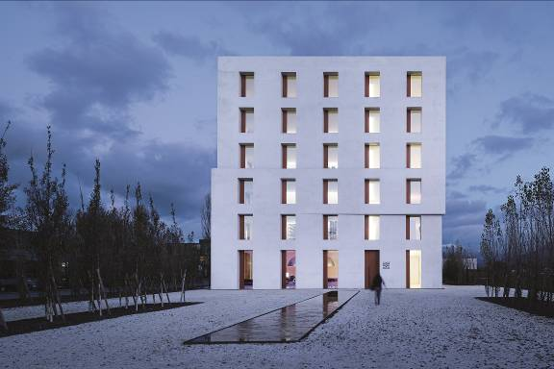
Caption 1: For the “2226” showcase project by architect Dietmar Eberle, Zumtobel has designed a tailor-made lighting concept.

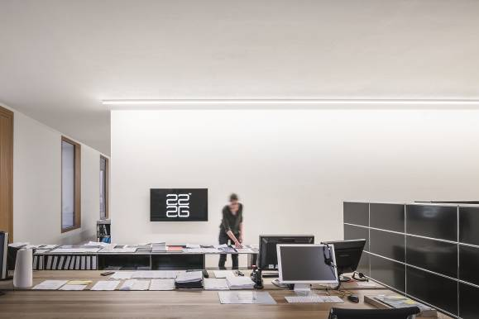

Caption 2: The office building accommodates Dietmar Eberle's architectural studio “be baumschlager eberle”, as well as other offices, a cafeteria and two art galleries. Zumtobel's lighting solution takes these various areas of the building into account and is able to perfectly adjust to many different lighting tasks.
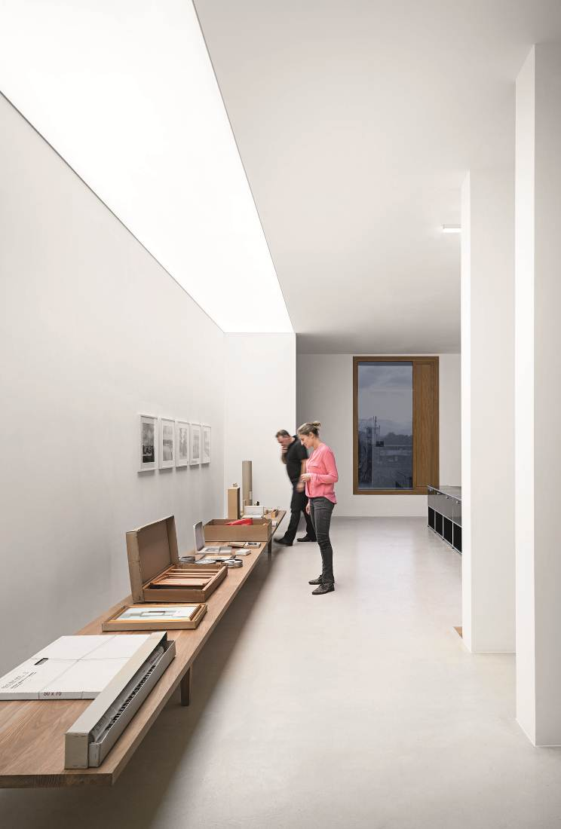

Caption 3: A central feature of the building is a selectively controlled LED-based luminous ceiling that runs all across the new building.

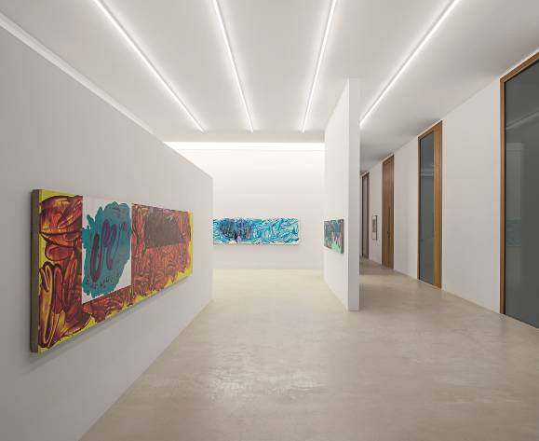
Caption 4: Throughout the building, Zumtobel has installed the decorative Linaria luminaire. Due to their extremely slim design, the discreet batten luminaires enhance the building's architecture and are particularly impressive in the art galleries, thanks to their unobtrusive design.

For more information, please contact:
Zumtobel Lighting GmbH  Sophie Moser  PR Manager  Schweizer Strasse 30  A-6851 Dornbirn  Tel. +43-5572-390-26527  Mobile +43-664-80892-3202  E-mail sophie.moser@zumtobel.com  www.zumtobel.com | Zumtobel Lighting GmbH  Daniel Lechner  Director Marketing Austria  Donau-City-Strasse 1  A-1220 Vienna  Tel +43 (1) 258 26 01 82875  Fax +43 (1) 258 26 01 982875  E-mail daniel.lechner@zumtobel.com  www.zumtobel.at
About Zumtobel
Zumtobel, a leading international supplier of integral lighting solutions, enables people to experience the interplay of light and architecture. As a leader in innovation, Zumtobel provides a comprehensive range of high-quality luminaires and lighting management systems for professional interior lighting in the areas of offices, education, retail, hotel & wellness, health, art & culture as well as industry. Zumtobel is a brand of Zumtobel AG with its head office in Dornbirn, Vorarlberg (Austria).
Zumtobel. The Light.

