Press release

A shining example of contemporary educational infrastructure
Zumtobel provides lighting solution for new campus of Vienna University of Economics and Business

The new campus of Vienna's University of Economics and Business is Austria's most advanced university complex. The area has been designed by six international star architects. For this large-scale international building project, Austrian lighting manufacturer Zumtobel has implemented a customised lighting concept based on flexibility and efficiency.

Dornbirn, September 2013 – After nearly four years of construction work, the new campus of Vienna's University of Economics and Business (WU) will open its doors in October 2013. Some 23,000 students and 1,500 staff members will be researching, studying and teaching on the premises. In an area of about 90,000 square metres, six internationally renowned architects have created a unique ensemble of buildings. The heart of the campus is the “Library and Learning Center” designed by Zaha Hadid, which includes a large auditorium and the main library, among other things. Grouped around it are five other university buildings designed by Hitoshi Abe (Sendai/Japan), Carme Pinós (Barcelona), Eduardo Arroyo (Madrid), Peter Cook (London) and Laura Spinadel (Vienna). In addition to high design aspirations, the client attached high importance to environmental considerations during erection of the buildings. The whole campus was therefore built in line with a so-called “green building” concept, which also included installation of an efficient and sustainable lighting system. Austrian lighting expert Zumtobel, based in Vorarlberg, could not fail to impress the designers and architects involved by implementing a complete customised lighting concept based on energy efficiency and flexibility. Zumtobel also boasts many years of experience in the management and handling of large-scale projects as well as comprehensive advisory know-how. For the various university buildings, Zumtobel developed custom lighting solutions incorporating numerous pendant luminaires, continuous row lighting systems, light lines and moisture-proof luminaires, and in total provided some 12,000 luminaires, in addition to a continuous row system of seven kilometres length. Zumtobel also coordinated the installation and commissioning of the luminaires, in collaboration with four electrical contractors. The order volume for luminaires and installation amounts to more than EUR 7 million.

In the “Library and Learning Center” as well as in three department buildings accommodating various university faculties and administration units, Zumtobel has installed some 5000 LED luminaires from the Panos Infinity range. These downlights mainly illuminate the staircases, corridors and escape routes in the building as well as the sanitary areas. They provide guidance to students and university staff, help them find their way and ensure pleasantly bright ambient lighting. In doing so, Panos Infinity features particularly high lighting quality and excellent efficiency. During normal operation, the LED luminaires consume significantly less energy than any comparable conventional solution and boast a longer service life as well. Compared to conventional standards, the LED solution has a payback period of only five to six years. Over and above this, the LED downlights can easily be integrated into a lighting management systems, so that the lighting in the staircases and sanitary areas of the university buildings can be efficiently controlled using presence detectors. In department building D3, Zumtobel has also demonstrated its flexibility in meeting individual requirements by developing a special housing for the downlights, since they could not be installed in the concrete ceiling. In these areas, light is also provided by Slotlight II luminaires. The continuous light line without a luminaire unit looks light a narrow lighting channel and provides pleasantly uniform lighting. Slotlight II hase also been installed in the staircase of the “Library and Learning Center”. The offices in the three largest department buildings are illuminated by Claris II pendant luminaires. The minimalist luminaire blends harmoniously into the room, providing accurate light direction and perfect glare control – which is especially important at computer workstations. In the basements and technical services centres of the five building complexes, Zumtobel has also installed the rugged Scuba luminaire, which is particularly soil- and water-resistant. Its uniform illuminance also ensures perfect orientation.

More information on the “WU campus” project:
Client: Projektgesellschaft Wirtschaftsuniversität Wien GmbH
Contractor: Bundesimmobiliengesellschaft (BIG); Wirtschaftsuniversität Wien (WU)
Architects: Library and Learning Center (LC): Zaha Hadid Architecture, Hamburg
Department D1 / Teaching Center: BUSarchitektur ZT GmbH, Vienna
Department D2 / Students Center: Atelier Hitoshi Abe, Sendai (Japan)
Department D3 / Administration: CRABstudio, London
Department D4: Estudio Carme Pinós S. L., Barcelona
Executive Academy: NO.MAD Arquitectos, Madrid

Facts & figures on Zumtobel products used
PANOS INIFINITY LED  http://www.zumtobel.com/panos_infinity | LED downlight range; dimmable; colour temperature 3000 K or 4000 K; high colour rendering index Ra > 90; luminaire efficiency > 84 lm/W; symmetrical beam pattern
SLOTLIGHT II  http://www.zumtobel.at/slotlight | Narrow light line without luminaire unit; ideal for three-dimensional geometries and corner areas; uniform light exit; colour temperature: 3000 K or 4000 K
CLARIS II  http://www.zumtobel.at/claris_II | Pendant luminaire in a minimalist design; ideal for office lighting and computer workstations thanks to glare control according to EN 12464 standard: L < 1000 cd/m² at 65° all-round; easy maintenance
SCUBA  http://www.zumtobel.com/scuba | Rugged moisture-proof luminaire, also suitable for outdoor areas; soil- and water-resistant thanks to 15° angle and smooth surface; high protection rating: IP 65

Captions:

(Photo credits: boanet.at)
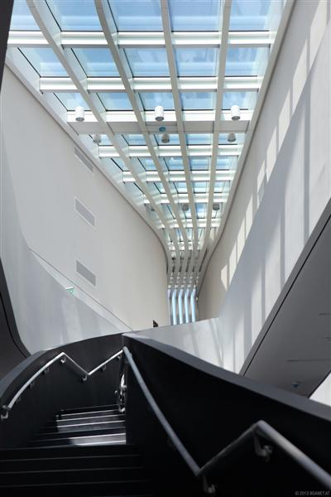

Image 1: In the three department buildings accommodating various university faculties and administration units as well as the in the “Library and Learning Center”, Zumtobel has installed some 5000 LED luminaires from the Panos Infinity range. Within the picture: Department D2 / Students Center: Atelier Hitoshi Abe, Sendai (Japan).

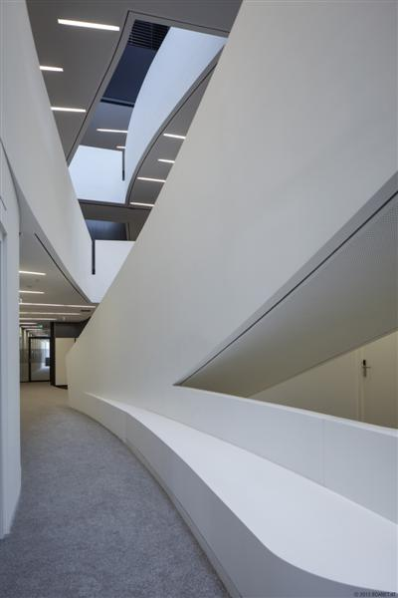

Image 2: At the Department 2, continuous light line Slotlight II provides pleasantly uniform lighting.

For more information, please contact
Zumtobel Lighting GmbH  Sophie Moser  PR Manager  Schweizer Strasse 30  A-6850 Dornbirn  Tel +43-5572-390-26527  Mobil +43-664-80892-3074  Email sophie.moser@zumtobel.com  www.zumtobel.com | Zumtobel Licht GmbH  Daniel Lechner  Marketing-Direktor Austria & CEE  Donau-City-Straße 1  A-1220 Wien  Tel +43 (1) 258 26 01 82875  Fax +43 (1) 258 26 01 982875  Email daniel.lechner@zumtobel.com  www.zumtobel.at

Brief profile
Zumtobel is a leading international supplier of integral lighting solutions that enable people to experience the
interplay of light and architecture. As a leader in innovation, the luminaire manufacturer provides a comprehensive
range of high-quality luminaires and lighting management systems for the most varied application
areas of professional interior lighting – including offices and educational facilities, presentation and retail,
hotels and wellness, health and care, art and culture as well as industry and engineering. Zumtobel is a brand
of the Zumtobel group with its head office in Dornbirn, Vorarlberg (Austria).

