Press release
Dornbirn, January 2012

Optimum task area lighting and decorative illumination in one
Zumtobel has implemented modern lighting concept for Duisburg office complex

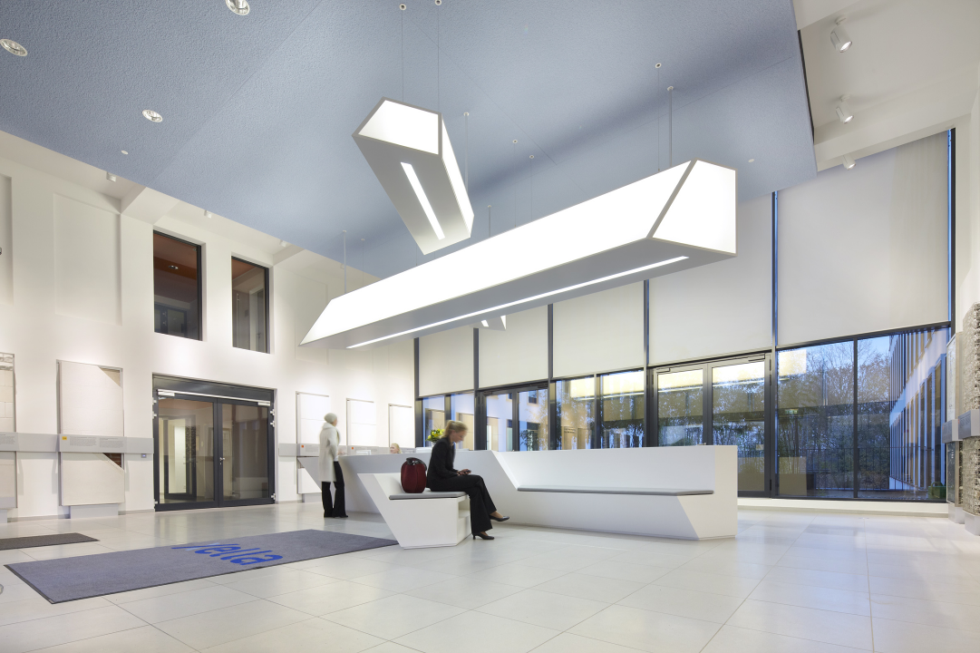Offices and workspaces these days have to meet numerous requirements, at the heart of which is always the individual. Room design and office lighting play an important role in improving the quality of the workplace and communication. High-quality lighting increases people's sense of well-being, boosts motivation and aids concentration. One example of the successful implementation of these requirements is the Duisburg building materials producers Xella. The two Design lighting design studio was commissioned to develop a modern lighting concept for the huge new 8,000 qm office complex in Duisburg. A sophisticated and very clear architectural and design language was required in the reception area while functional lighting was the focus for the offices. To this end Claudia de Bruyn, interior designer at two, drew on the technical lighting expertise of Zumtobel. "We have worked together successfully in the past" explains the lighting designer. "That time the complex materials and technological knowledge of the people at Zumtobel was key. This has been equally the case for the custom luminaire in the reception area."
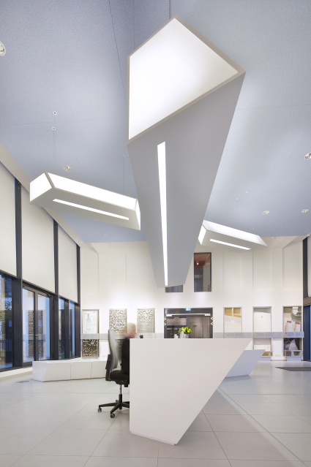
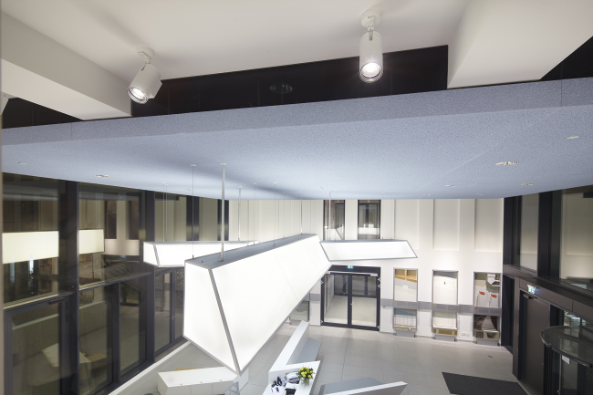
The large X-shaped luminaire, which forms the initial letter of the Xella company name, elegantly dominates the spacious foyer. In pendant form it mirrors the X-shaped counter beneath. Placed centrally above the elegant white seamless counter, observers may need to look twice before noting the charming allusion to the company name. Despite its size and straight lines, the luminaire is distinctly light and airy in feel. This is thanks in part to the luminaire unit which is fully and uniformly illuminated from inside. The luminaire however not only provides soft, gentle ambient lighting. To ensure adequate brightness at the counter, narrow luminous strips are integrated flush into the underside of the custom luminaire. Their direct light provides staff at reception with sufficient glare-free light for working at the screen. LED spots installed at the transitions to the office rooms set extra small lighting accents which create a pleasant contrast to the uniform ambient lighting. The spots can for example highlight in a nuanced way the building materials displayed on the walls and create a lively contrast to the otherwise calm ambience. Using Zumtobel's Luxmate Basic lighting management program the luminaires can also be switched and programmed on the basis of daylight. The foyer has a fully glazed façade to the street, and particularly at twilight and dawn it creates a bright pool of light when the room, bathed in a pleasant warm white colour temperature, appears to cast its light outwards.
The reception area is the focal point of the office complex. A total of three tranches of offices branch off from here to the left and right. The corridors, lit with highly efficient Zumtobel LED downlights, lead into many small offices with one or two workstations. Here, the lighting designers have made use of another custom product; this one has been tried and tested. The Clearcell pendant luminaire, originally developed jointly with Zumtobel, has been converted into a free-standing luminaire. Providing direct or indirect light it is the main source of light for the offices and also the conference rooms. While indirect light gently brightens up the room, direct light provides perfect visual comfort at the desk. The micro-cell louvre comprises individual louvre modules which distribute extremely uniform light. The basic material is transparent, giving the louvre a particular translucence. Therefore the identical lighting technology used illuminates the luminaire housing, and the luminaire itself becomes an architectural feature and a visual focal point.
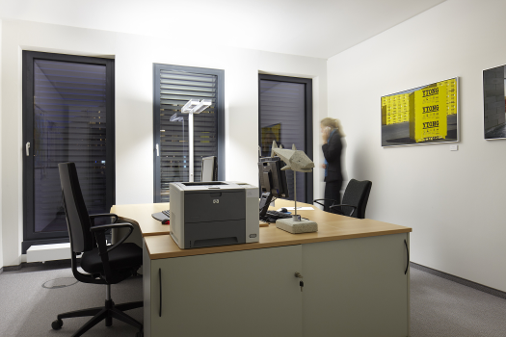
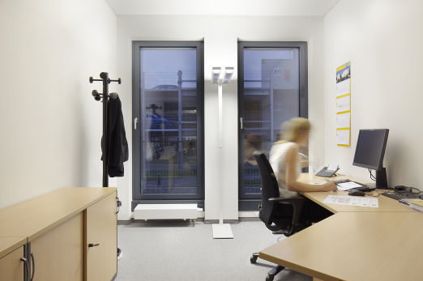
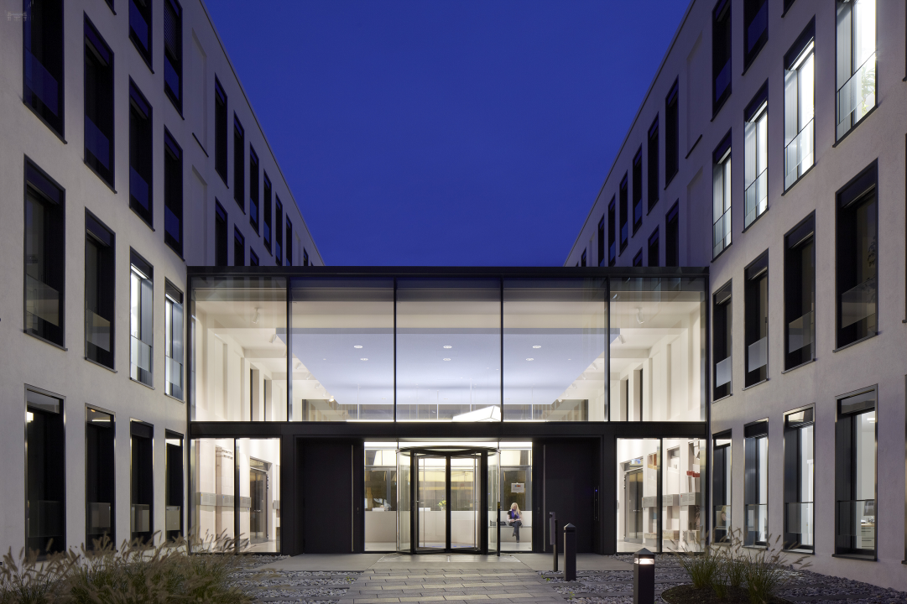
All in all therefore, the new office complex provides modern and impressive workplace conditions in which people feel at ease and concentrated and motivated in their work. Zumtobel. The Light.
Fact box: Xella, Duisburg/D
Client: ZPP - Zweite Primus Projekt GmbH, Düsseldorf/D
Architects: Heine Planungsgesellschaft mbH, Hamburg/D
Lighting design: two_product+space+think, Claudia de Bruyn, Ratingen/D
Electricalinstallations: MDB Elektroanlagenbau, Hünxe/D
Lighting solution: Zumtobel
X-shaped custom luminaire, CLEARCELL free-standing luminaires, PANOS INFINITY LED downlights, ARCOS LED spotlights, LUXMATE Basic lighting management system

Brief profile
The Zumtobel brand is a leading international supplier of integral lighting solutions that enable people to experience the interplay of light and architecture. As a leader in innovation, the luminaire manufacturer provides a comprehensive range of high-quality luminaires and lighting management systems for the most varied application areas of professional interior lighting – including offices and educational facilities, retail and presentation, hotels and wellness, health and care, art and culture as well as industry and engineering. Zumtobel is a brand of the Zumtobel AG group with its head office in Dornbirn, Vorarlberg (Austria).

Captions:

B1_ The custom luminaire designed by two Design together with Zumtobel is a striking example of how light and luminaires can be transformed into a unique brand communicator.

B2_ The Clearcell free-standing luminaire designed by two Design is ideal for high-quality office lighting.

B3_ The brightly illuminated foyer is an attractive focal point for passers-by in the evening.

For more information, please contact:
Zumtobel Lighting GmbH
Nadja Frank
PR Manager
Schweizer Strasse 30
A-6851 Dornbirn

Tel. +43-5572-390-1303
Fax +43-5572-390-91303
nadja.frank@zumtobel.com
www.zumtobel.com
Publication of this document is free if due acknowledgement is made: Zumtobel

