Press release

SEQUENCE: for adaptive, pinpoint task area lighting
Zumtobel is launching an LED luminaire that meets employees' various requirements for ideal office lighting and satisfies the need for empowerment to the fullest possible extent - it is called Sequence. Sequence offers an optimum combination of direct and indirect lighting and boasts modules than can be individually controlled.
Dornbirn, March 2014 – Modified forms of collaboration, conventionally desk-based, in project teams or in open plan offices: nowadays people demand differentiated lighting solutions that are capable of adjusting to their needs and the tasks in hand. The technology of the Sequence pendant and surface-mounted LED luminaire meets precisely these user needs. Developed from scratch – not just its design, but also all its electronic and control systems – this luminaire exploits the capabilities of modern LED technology to the full.
Sequence has been designed as a pendant or surface-mounted luminaire and consists of 8 or, optionally, 14 side-by-side module units of identical design, each with 6 x 3 centrally located LED lighting points. Special lens technology with symmetrical or asymmetrical distribution characteristics in front of each of the 18 central LEDs ensures perfectly directed task lighting with good glare control. This prevents annoying reflections on screens, tablets or smartphones. At the same time, thanks to an opal cover frame, the 24 outer LEDs provide diffuse ambient light and altogether softer light distribution.

Individually controllable modules
Grouped together in three logical sets (each consisting of 4 outer modules and 6 inner modules), the individual modules, as well as the indirect light component, are individually controllable. Each set has a DALI address. The electronic control system, specially developed for Sequence, ensures gentle transitions between modules, despite the fact that there are only four addresses for 14 modules. This makes adaptive lighting possible.

Besides this exceptional performance feature, Sequence, thanks to its flat aluminium housing, boasts an especially slim shape that blends perfectly into any interior design. The luminaire's sophisticated design – all its electronic components are almost invisibly enclosed in a slightly raised area on the top of the luminaire unit – ensures a delicate appearance.

Sequence is available with a colour temperature of 3000 K (warm) and 4000 K (intermediate). Zumtobel supplies this luminaire in lengths of 1200 mm (6 LED modules) or 2100 mm (14 LED modules).

Captions:
(Photo credits: Zumtobel)
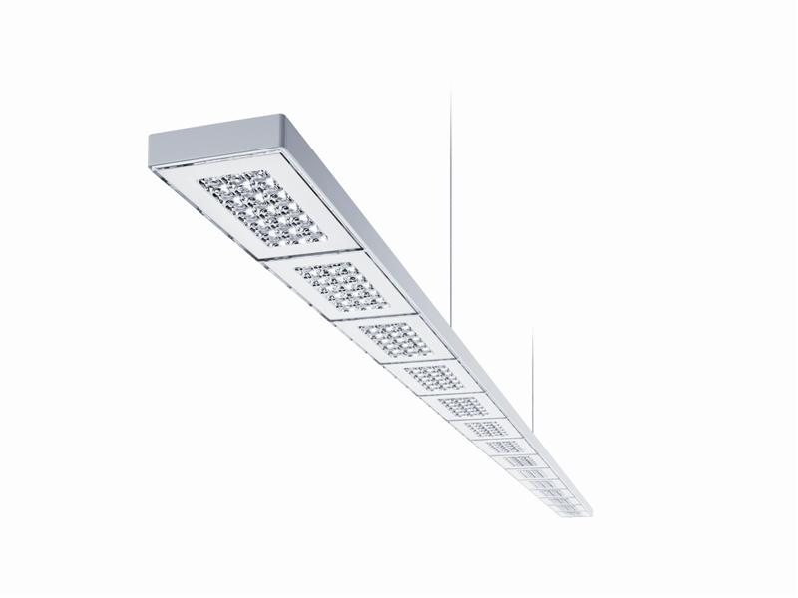
Caption: 1: For adaptive, pinpoint task area lighting
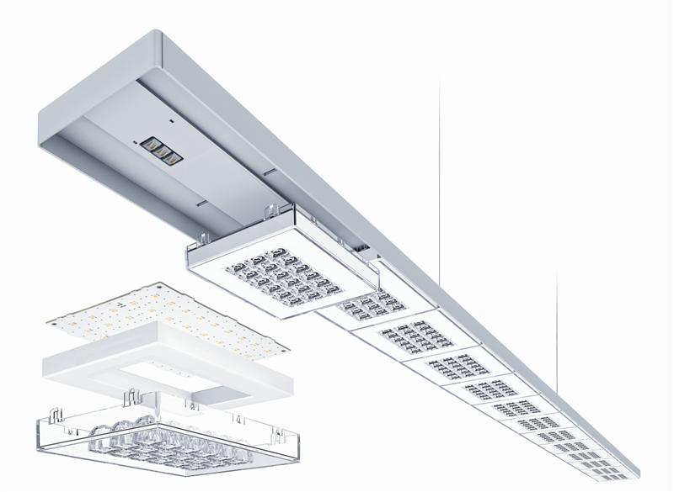
Caption 2: Sequence has been designed as a pendant or surface-mounted luminaire and consists of 8 or, optionally, 14 side-by-side module units of identical design, each with 6 x 3 centrally located LED lighting points.

Press contact:
Zumtobel Lighting GmbH
Sophie Moser
PR Manager
Schweizer Strasse 30
A-6851 Dornbirn

Tel +43-5572-390-26527
Mobile +43-664-80892-3074
E-mail sophie.moser@zumtobel.com

www.zumtobel.com

About Zumtobel
Zumtobel, a leading international supplier of integral lighting solutions, enables people to experience the interplay of light and architecture. As a leader in innovation, Zumtobel provides a comprehensive range of high-quality luminaires and lighting management systems for professional interior lighting in the areas of offices, education, presentation & retail, hotel & wellness, health, art & culture as well as industry. Zumtobel is a brand of Zumtobel AG with its head office in Dornbirn, Vorarlberg (Austria).
Zumtobel. The Light.

