Press release
LIGHT FIELDS evolution: LED luminaire range for sophisticated lighting projects
LED luminaire range for office applications
Zumtobel presents the Light Fields evolution LED luminaire range for use in modern office environments involving a variety of requirements. Light Fields evolution combines uncluttered design with innovative technology: the result is an LED luminaire range comprising recessed, pendant, surface-mounted, wall-mounted and free-standing luminaires in a uniform and slim design perfectly in line with contemporary office architecture.
Dornbirn, November 2013 - No matter whether you work at a computer or tablet PC, use a smart phone, attend a meeting or hold a presentation: the LED luminaire range cannot fail to impress on account of its perfect lighting quality without producing any glare. This is made possible by the patented micro-pyramidal optic (MPO+). The diffuser layer of the optic resolves the LED points uniformly, ensuring perfectly glare-free light. Even at high luminous flux levels, luminance is consistently reduced, providing pleasantly distributed light even at steep radiation angles. Two colour temperatures are available for the luminaire range (3,000 K and 4,000 K). With a luminaire efficiency factor of up to 105 lm/W, the luminaires reduce the building's energy consumption, thus making a significant contribution towards sustainable added value.
All luminaires of the Light Fields evolution range boast excellent lighting quality and energy efficiency levels. Innovative technologies are used in various luminaire types with the aim of providing the best light for people in many different office situations.
For the recessed, surface-mounted and wall-mounted luminaires, Zumtobel has developed the 3Dprotect reflector. The reflector (patent pending) is both protection and optic at the same time. Its 3D structure protects the LED modules during installation, preventing damage from electrostatic discharge. At the same time, the structure's high reflection factor allows to increase the luminaire efficiency level.

The slimline design with a height of only 28 mm is made possible because the light emitting diodes have been integrated into the frame of the pendant luminaire. In order to obtain a well-balanced indirect/direct light ratio, LED light is emitted downwards thanks to litePrint light guide technology. The precisely calculated dot matrix of the litePrint light guide ensures uniform illumination of the complete light emitting panel. At the same time, an exactly defined light component is directed upwards, in specific regions, via openings in the luminaire housing, so that no extra LED modules are required for the indirect component.

Plenty of creative scope for modern office environments that are often modified is provided by the free-standing luminaire. Available with three different luminous flux levels (7,800, 11,000 und 14,800 lm) as well as warm and intermediate colour temperatures, the Light Fields evolution free-standing luminaire offers a variety of application options. The swarmControl technology used here is characterised by two functions that ensure a new dimension of individual lighting quality at workstations: the corridor function and the presence-based function. The fiormer primarily provides for safety and orientation, as the luminaires are dimmed up one by one by means of a built-in presence detector, thus indicating the way to the workstation. The presence-based function, on the other hand, ensures ideal lighting conditions with a mean illuminance level of up to 500 lx at the workstation, while users may adjust the quantity of light to their personal needs at any time using a control panel in the luminaire base. Neighbouring luminaires communicate via swarmControl, providing a cloud of light that creates a pleasant working atmosphere. The sensControl III function increases the free-standing luminaire's efficiency even more. The presence detector automatically switches the luminaire on and switches it off again when the workstation is left unattended. A brightness sensor monitors the illuminance level across the desktop and dims the luminaire depending on the quantity of daylight or artificial light available. Thus, up to 70 percent of energy can be saved, compared to conventional switchable free-standing luminaires.

Facts & figures
Recessed, surface-mounted, pendant, free-standing and wall-mounted LED luminaire
Design by Chris Redfern, Sottsass Associati
Aluminium, recessed luminaire optionally available in white
Pendant luminaire | 1,518 x 268 mm  5370 lm (4,000 K)
Recessed luminaire | M 600: 297 x 297 mm  M 625: 309 x 309 mm  1,600 lm
Recessed luminaire | M 600: 597 x 597 mm  M 625: 622 x 622 mm  3,780 lm high efficiency  4,400 lm high output
Recessed luminaire | M 600: 1,197 x 297 mm  M 625: 1,247 x 309 mm  3,780 lm high efficiency  4,400 lm high output
Recessed luminaire | M 600: 1,497 x 297 mm  M 625: 1,547 x 309 mm  4,600 lm high efficiency  5,500 lm high output
Surface-mounted luminaire | 324 x 324 mm  1,400 lm
Surface-mounted luminaire | 636 x 636 mm  4,500 lm  5 % indirect lighting
Surface-mounted luminaire | 1518 x 268 mm  4,500 lm  5 % indirect lighting
Free-standing luminaire | M: 616 x 276 x 1950 mm  7,800 lm  11,000 lm  14,800 lm

Captions:
(Photo credits: Zumtobel)
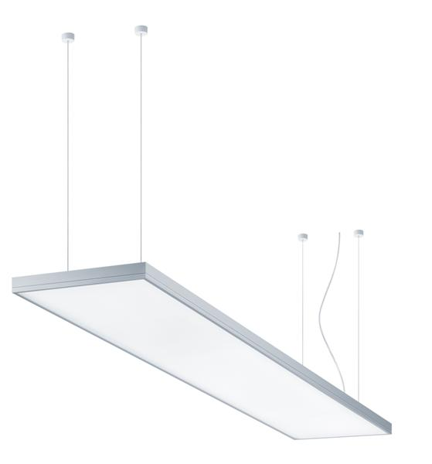
Caption 1: Light Fields evolution combines uncluttered design with innovative technology
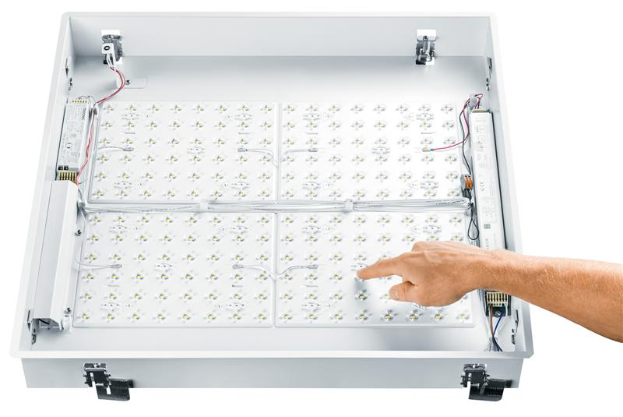
Caption 2: The 3Dprotect reflector protects the LED modules, effectively preventing damage by electrostatic discharge during installation.
Caption 3: Thanks to litePrint light guide technology (patent pending), light is emitted downwards by way of specifically developed laser engraving, resulting in uniform light distribution.

For more information, please contact:
Zumtobel Lighting GmbH  Nikolaus Johannson  Head of Brand Communication  Schweizer Strasse 30  A-6851 Dornbirn  Phone: +43 (0) 5572 390-26427  Mobile: +43-(0)-664-80892-3202  E-mail: nikolaus.johannson@zumtobel.com  www.zumtobel.com | Zumtobel Lighting GmbH  Sophie Moser  PR Manager  Schweizer Strasse 30  A-6851 Dornbirn  Phone: +43-5572-390-26527  Mobile: +43-664-80892-3074  E-mail: sophie.moser@zumtobel.com  www.zumtobel.com

About Zumtobel
Zumtobel is a leading international supplier of integral lighting solutions that enable people to experience the interplay of light and architecture. As a leader in innovation, the luminaire manufacturer provides a comprehensive range of high-quality luminaires and lighting management systems for the most varied application areas of professional interior lighting – including offices and educational facilities, presentation and retail, hotels and wellness, health and care, art and culture as well as industry and engineering. Zumtobel is a brand of Zumtobel AG with its head office in Dornbirn, Vorarlberg (Austria).

Zumtobel. The Light.

