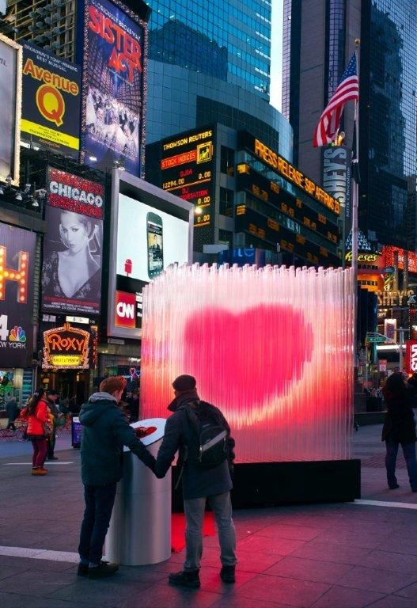
Press release
Dornbirn, February 2012

Romance on Times Square
LED luminaires by Zumtobel make Valentine's Day Heart pulsate

On Valentine's Day, there will be romance on Times Square in New York. This year, Bjarke Ingels Group (BIG) architects from Denmark have provided the “City Pulse” heart sculpture made of 400 transparent acrylic tubes fitted with LEDs, which radiates light in the midst of the urban bustle. Lighting solutions expert Zumtobel has sponsored the LED lighting system that illuminates this work of art.
The Times Square Alliance marketing consortium in New York has implemented the Valentine's Day Heart for the fourth time in a row. In collaboration with renowned artists and architects, the subject of love is elaborately set centre stage. BIG♥NYC by BIG (Bjarke Ingels Group) is the title of this year's project. The leitmotif of the installation created by the Danish architects is “more people = more love”. A single person can activate the beating heart by touching the panel set up next to the installation. The more people take each other by the hand to form a human chain, the faster will the heart pulsate to finally climax in a brightly burning heart. In this way, an impressive lighting scenario is created by focusing human energy – a luminescent symbol of love, so to speak.

The three-metre tall luminescent sculpture is made of 400 transparent acrylic tubes fitted with LEDs. They form a cube around the red Valentine's Day Heart, which reflects the city lights. The heart itself seems to hover in the air.
“City Pulse” is tangible proof that lighting experiences are always a piece of culture, a piece of art as well. For Zumtobel, communication and exchange in the context of international project partnerships with architects, light designers and artists is an important issue. The joint development of project-related special solutions individually adjusted to specific requirements provides valuable stimuli to innovation for light to be used as a means of creative design.
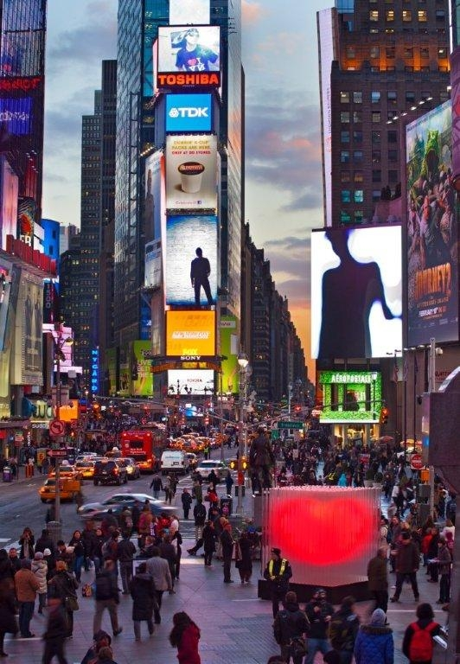

The 2012 Valentine's Day Heart was officially inaugurated on 6 February. On 14 February, many couples will use Times Square as a unique backdrop for renewing their marriage vows.

Zumtobel. The Light.

Project information: BIG ♥ NYC
Collaboration: Times Square Alliance, BIG, Flatcut, Local Projects, Zumtobel

Brief profile
The Zumtobel brand is a leading international supplier of integral lighting solutions that enable people to experience the interplay of light and architecture. As a leader in innovation, the luminaire manufacturer provides a comprehensive range of high-quality luminaires and lighting management systems for the most varied application areas of professional interior lighting – including offices and educational facilities, retail and presentation, hotels and wellness, health and care, art and culture as well as industry and engineering. Zumtobel is a brand of the Zumtobel AG group with its head office in Dornbirn, Vorarlberg (Austria).

Captions:
B1_ Times Square Alliance, BIG, Flatcut, Local Projects and Zumtobel celebrate the Valentine’s Day with an interactive heart installation at Times Square, New York

B2_ BIG♥NYC, the 10-foot tall glowing heart sculpture consists of 400 transparent, LED lit, acrylic tubes

Credits:
Images for online publication only, to be credited © David Sundberg/Esto
For use in print publication please contact photographer directly:
Erica Stoller, www.esto.com, +1914 698 4060 who will charge a fee

For more information, please contact:
Zumtobel Lighting GmbH
Nadja Frank
PR Manager
Schweizer Strasse 30
A-6851 Dornbirn

Tel. +43-5572-390-1303
Fax +43-5572-390-91303
nadja.frank@zumtobel.com
www.zumtobel.com

