Press release
Dornbirn, May 2012

Marriot relies on convenient lighting management by Zumtobel
260 ZBOX lighting control systems for new hotel in Baku

The new 5-star JW Marriott Hotel in Baku offers both business and leisure travellers superb high-end comfort. Even the lighting seems to cater automatically for guests' preferences – thanks to a cutting-edge Zumtobel ZBOX lighting management system that is used in all the hotel's 243 room.

Many eyes will be fixed on Baku, the capital of Azerbaijan, on May 26, because this year Baku is hosting the 57th Eurovision Song Contest, Europe's largest music competition. Even without the Song Contest, Baku is an impressive city of 2 million inhabitants. The most populous and largest city in the entire Caucasus region is a transport hub as well as an economic and cultural centre that is home to various universities, research institutes, theatres and museums. No wonder the Marriott hotel chain has just opened a new 5-star hotel in Baku.

The JW Marriott Absheron Baku Hotel is located close to the city centre between futuristic office buildings and the historic old town. It offers its guests extremely high levels of comfort that meet every imaginable up-to-the-minute standard. This includes the lighting concept in the hotel rooms, which was implemented by luminaire manufacturer Zumtobel. Zumtobel won the contract to equip all 243 rooms and suites with its advanced ZBOX lighting management system.

ZBOX – Making it easy to control light
Peter Roos, Head of Strategic Global Networks at Zumtobel, explains: "With ZBOX we are able to supply hotel operators with a multifunctional, flexible, energy-saving lighting control system that also provides hotel guests with individual lighting scenes that they can recall at the press of a button. The actual guest decides which lighting ambience he or she wants and can adjust it to suit his or her needs. Zumtobel supplies the ZBOX lighting management system as an all-inclusive package – each complete with four innovative Circle control points and a central control unit. The system is fully pre-addressed – and comes with connectors for dimming, presence detection, door lock systems or blinds control.

Guests enjoy a care-free stay
The ZBOX's convenient features and benefits are obvious: guests in the contemporarily styled rooms of the JW Marriott Hotel are faced with intuitive control points rather than a bewilderingly large number of switches. Roughly the same size as a standard on/off switch, these Circle control points fulfil all the basic functions of a sophisticated control panel. To call up any of three programmed lighting scene, all guests have to do is press a button with the respective icon on it. The ZBOX then conjures up perfect lighting for applying make-up, watching TV, reading or taking a bath. Various lighting scenes can be generated equally straightforwardly and dynamically. "Our guests reap the benefit of the great flexibility and functionality of Zumtobel lighting as well as intuitive operation. This gives them a unique level of convenience that allows them to adjust the lighting themselves to suit their respective needs" points out Petra Maluck, International Project Management Marriott International Inc..

The central control unit, the ZBOX controller, is tuned to both the guest's lighting needs and the hotel operator's requirements: connectors for hotel card switches and door locking systems ensure a pleasant, inviting lighting scene when the guest enters the room. The ability to integrate the ZBOX into a modern building management system makes an intelligent contribution towards energy-efficient, low-cost operation of the hotel. Using ZBOX makes it possible to obtain energy savings of up to 25 % – not to mention greater lighting convenience for hotel guests.

Zumtobel. The Light.
Fact box:
Client: Marriott International Inc.
General contractor: Strabag, Vienna/A
Developer: PASHA Construction, Baku/AZ
Architecture: ReardonSmith Architects, London/UK
Interior design: WA International, Dubai/AE
Electrical consultants: EC Harris

Lighting solution: Zumtobel
ZBOX lighting management system, LUXMATE LRA2500 automation processor and LM-GO graphical visualisation

Brief profile
Zumtobel is a leading international supplier of integral lighting solutions that enable people to experience the interplay of light and architecture. As a leader in innovation, the luminaire manufacturer provides a comprehensive range of high-quality luminaires and lighting management systems for the most varied application areas of professional interior lighting – including offices and educational facilities, presentation and retail, hotels and wellness, health and care, art and culture as well as industry and engineering. Zumtobel is a brand of the Zumtobel group with its head office in Dornbirn, Vorarlberg (Austria).

For more information, please contact:

Zumtobel Lighting GmbH Zumtobel Lighting GmbH
Nikolaus Johannson Nadja Frank
Head of Brand Communication PR Manager
Schweizer Strasse 30 Schweizer Strasse 30
A-6850 Dornbirn A-6850 Dornbirn

Tel. +43-5572-390-26427 Tel. +43-5572-390-1303
Fax +43-5572-390-926427 Fax +43-5572-390-91303
nikolaus.johannson@zumtobel.com nadja.frank@zumtobel.com
www.zumtobel.com www.zumtobel.com

Captions:
Credits: Zumtobel

Caption 1:
The JW Marriott Abershon Hotel in Baku opened in December. The first Marriott hotel in Azerbaijan offers guests extremely luxurious levels of comfort.

Caption 2:
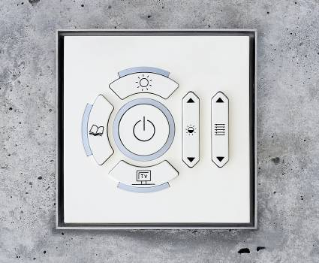

Zumtobel's ZBOX lighting control system ensures that guests always enjoy appropriate lighting. Intuitive control points make the calling up of various lighting scenes child’s play.

Caption 3:
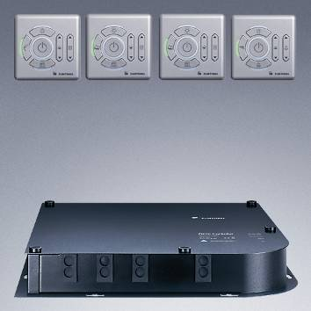

The lighting management system is supplied as an all-inclusive package. Its sophisticated technology remains completely hidden from guests. The Circle control points are clearly laid out and can be operated intuitively as required – whether guests want to watch TV, read or apply make-up.

Caption 4:
An assortment of restaurants, a fitness centre and a pool that offers a panoramic vista over the Caspian Sea from the 22nd floor. Guests' every whim is catered for at the JW Marriott Abershon Hotel in Baku.

