Press release

A “shining example”
Sustainable lighting solution by Zumtobel for the first timber hybrid high-rise building

The LifeCycle Tower One in Dornbirn is the world' first uncased timber high-rise building. It sets new standards with respect to sustainability, efficient use of resources and quality of life. For this award-winning building, Zumtobel has developed a trend-setting lighting concept that includes an intelligent lighting control system to maximise lighting comfort and increase efficiency.

Dornbirn, April 2013 – The LifeCycle Tower One (LCT One) is the world's first eight-storey timber hybrid high-rise building.Based on the latest scientific findings in combination with innovative technologies and a resource-saving method of construction, LCT ONE indicates the way into the future of urban architecture.Inside the building, one can see the supporting structure made of timber; the external façade is clad in aluminium. The prototype was opened in 2012 and is mainly used for office purposes. For the LCT One, Zumtobel has developed an integral lighting concept including lighting management, emergency lighting and alternative lighting solutions for the offices. Apart from the modern and perfectly glare-free office luminaires as well as energy-saving LED corridor lighting, Zumtobel's Luxmate Litenet lighting management system is used in the LCT One. It controls the lighting, emergency lighting and blinds.

Intelligent lighting management
Luxmate combines complex system features such as use of daylight, presence detectors, integration of emergency lighting, and predefined room profiles in one central unit that can be easily operated. The daylight available is perfectly integrated into the lighting solution by the control system. The daylight sensor on the roof of the building continually monitors the incident light, ensuring that in each room only the quantity of artificial lighting is added that is required. Luxmate also controls the blinds, which in automatic mode can be adjusted to the prevailing lighting conditions and sunlight. This prevents glare and excessive build-up of heat in the rooms. Another feature of the lighting control system is the flexible change of colour temperatures and the quantity of light. Dynamic lighting demonstrably has a major impact on people's sense of well-being and productivity. Carefully thought-out lighting scenes are defined in advance, stored, recalled and modified as required. Moreover, Luxmate controls the entire LED emergency lighting system. This ensures low maintenance effort.

The latest in lighting technology: flexible and user-oriented
Panos Infinity high-performance LED spotlights, among others, have been installed in the ceiling. The general lighting system also includes Supersystem spots for accent lighting. The lighting concept is backed by presence detectors, which allow for intelligent control and lighting.This means that perfect lighting is available only when it is actually needed. The presence detectors used for the lighting solution also control the heating. In order to reduce energy consumption, presence detectors have been installed in the transit areas, corridors, toilets and in the staircase as well.

Exemplary energy efficiency
Using an intelligent lighting management system such as Luxmate, energy can be saved on a permanent basis: presence detectors or pre-defined switch-on times allow for potential savings of 20 to 40 percent. By making optimised use of daylight, up to 75 percent of lighting energy can be saved. Using dimmable luminaires, energy consumption can be reduced further by some 25 percent. Properly coordinated control of lighting and blinds reduces the cooling load of a building and improves lighting quality as well. The result is greater independence in the face of energy price increases and a sustainable drop in costs and CO₂ emissions.

Captions:

(Photo credits: Zumtobel)

Caption 1: The LifeCycle Tower is the world's first timber high-rise buildings. It features an aluminium façade.

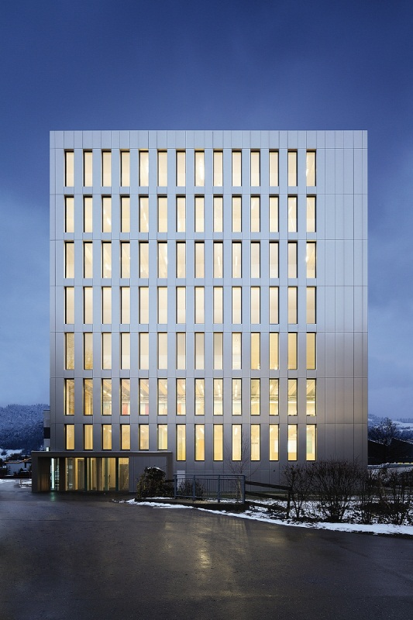

Caption 2: An external daylight sensor installed on the roof monitors the daylight available to integrate it into the lighting concept.

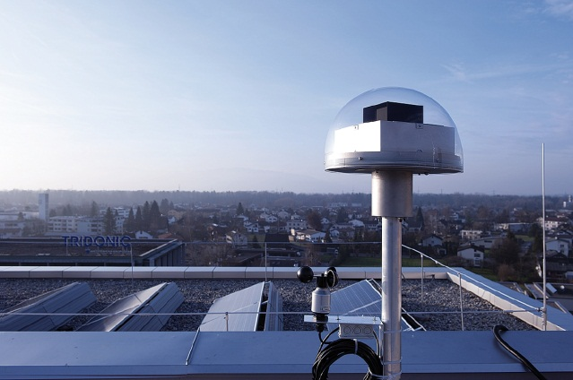

Caption 3: The highly efficient Panos Infinity LED spotlights feature a high colour rendering index and symmetrical light distribution.

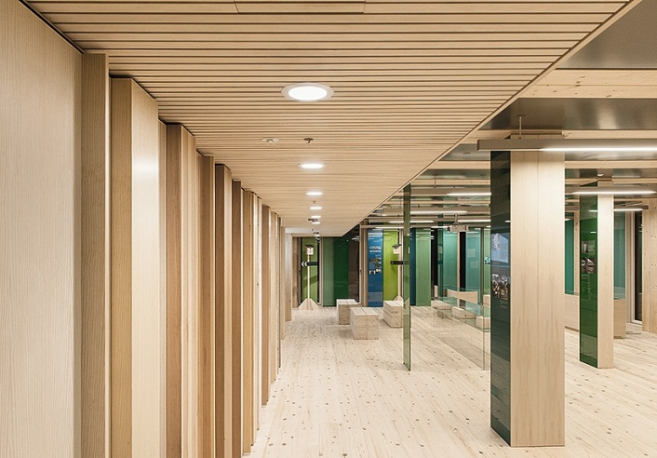

For more information, please contact:
Zumtobel Lighting GmbH
Nikolaus Johannson
Head of Brand Communication
Schweizer Strasse 30
A-6851 Dornbirn

Tel +43-5572-390-26427
Mobile +43-664-80892-3202
Email nikolaus.johannson@zumtobel.com

www.zumtobel.com

About Zumtobel
Zumtobel is a leading international supplier of integral lighting solutions that enable people to experience the interplay of light and architecture. As a leader in innovation, the luminaire manufacturer provides a comprehensive range of high-quality luminaires and lighting management systems for the most varied application areas of professional interior lighting – including offices and educational facilities, presentation and retail, hotels and wellness, health and care, art and culture as well as industry and engineering. Zumtobel is a brand of Zumtobel AG with its head office in Dornbirn, Vorarlberg (Austria).

Zumtobel. The Light.

