Press release
Dornbirn, November 2011

Light and the origin of the universe
Interview with Daniel and Noam Libeskind on the eL Masterpiece

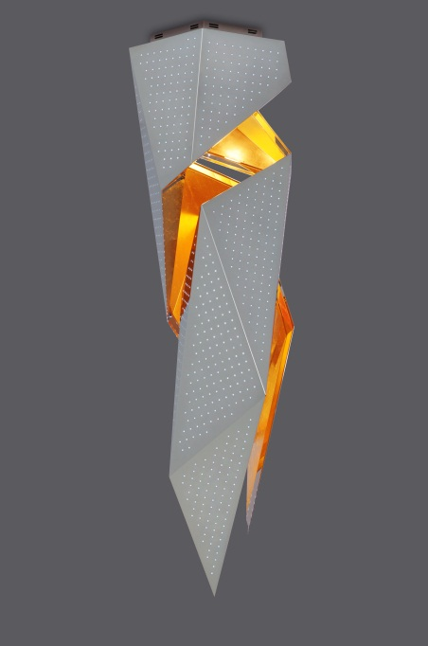
Zumtobel develops unique lighting projects in collaboration with architects, designers and artists. The result of this creative co-operation are luminaires incorporating cutting-edge lighting technology and featuring impressive design – Zumtobel's Masterpieces. At Art Basel Miami Beach, Zumtobel will present the new “eL” Masterpiece by Daniel Libeskind for the first time, on an exclusive basis. His son, astrophysicist Dr. Noam Libeskind, has developed an algorithm for the “eL” which is transferred onto the luminaire in the form of dynamic lighting scenes representing the development of the universe in a most fascinating way. In the interview, the architect and his son talk about architecture, the Masterpiece and collaboration with Zumtobel.

Which changes in architecture over the past ten years do you consider most important?
Daniel Libeskind: What is most important, in my opinion, is that architecture has left its own spheres to go out into the world again. People have realised that architecture actually plays a vital role in their lives. Architecture is part of an ever-developing history that is concerned with the past, with memories and with new ideas.

Are there any rules in architecture, in the context of the past and new ideas that will remain valid forever?
Daniel Libeskind: Architecture is like anything that survives – it is based on beauty and authenticity. These are really ancient categories that have existed for thousands of years, everywhere – not only in the Western world. I think that these categories will remain valid despite all changes, fashion fads and technologies; I believe that architecture must be judged as great art in this sense. Of course, these terms as such are not easy to define – what is beautiful today may not have been considered beautiful two days ago. Yet it is a standard that is absolute. I would not spend my time with architecture if I considered it only an ephemeral phenomenon.

You have developed a Masterpiece in collaboration with Zumtobel. Could you briefly explain the basic ideas you had, with respect to design and the function of light within the luminaire, after having accepted this commission?
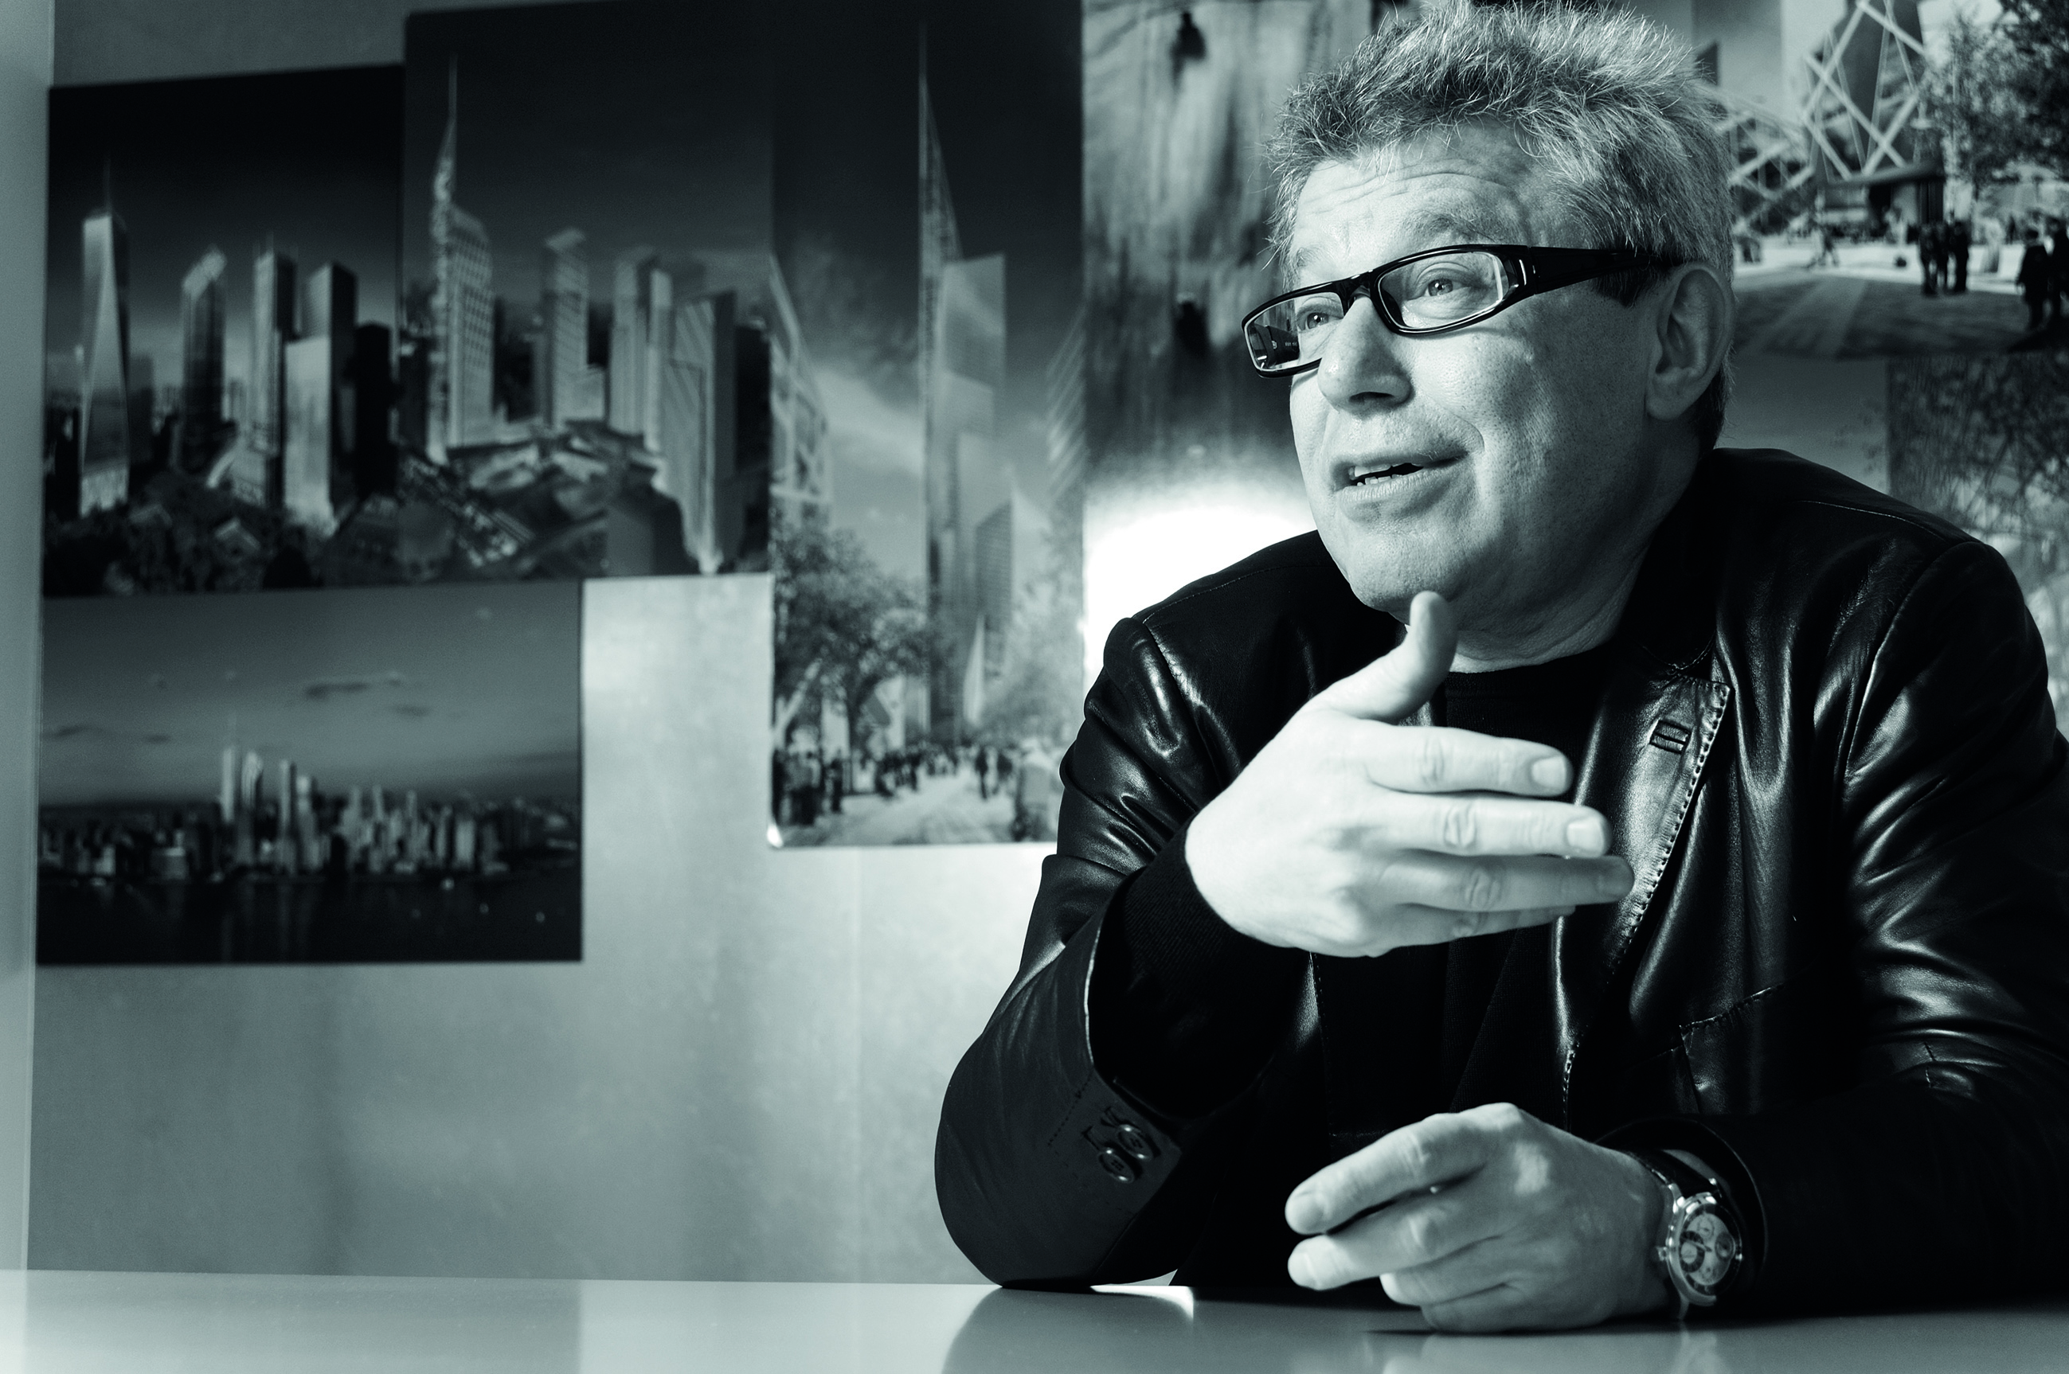
Daniel Libeskind: I wanted to design a truly unique object, one that gives off light in a way that is natural, that encapsulates the complexity and interesting quality of the very light that surrounds us. Since the theory of relativity, we know much more about the absolute speed of light and its direct connection to the origins of the universe; we know that light is life. With this in mind, I wanted my design to not simply be about the mechanism or the formalistic use of light, but instead about creating a truly new experience that will add a dimension to the demonstration of the mystery, wonder and beauty of light. I think the perfect luminaire should behave like light itself. Light is a mysterious and complex phenomenon; because even in darkness there is light. So to me, light and desire are very closely related: the desire for light and the reciprocal movement of light back to the source. This is a significant undertaking and there is a big adventure here to be explored through design. I believe light is only now emerging onto centre stage – it’s no longer just a footnote to architecture or a background, but something central to our thinking.

A question to the cosmologist Noam Libeskind: why does light play such an important role in our universe?
Noam Libeskind: In many ways, light is the most important factor in the entire universe. Light takes on in a variety of forms: starlight, sunlight, our Sun. Light is also the basis of all life on Earth. Just imagine our planet without the Sun! Even if most of the energy available in the universe is based on atoms and matter, the universe could not exist without light.
What exactly is the relationship between your Masterpiece and the origins of the universe?
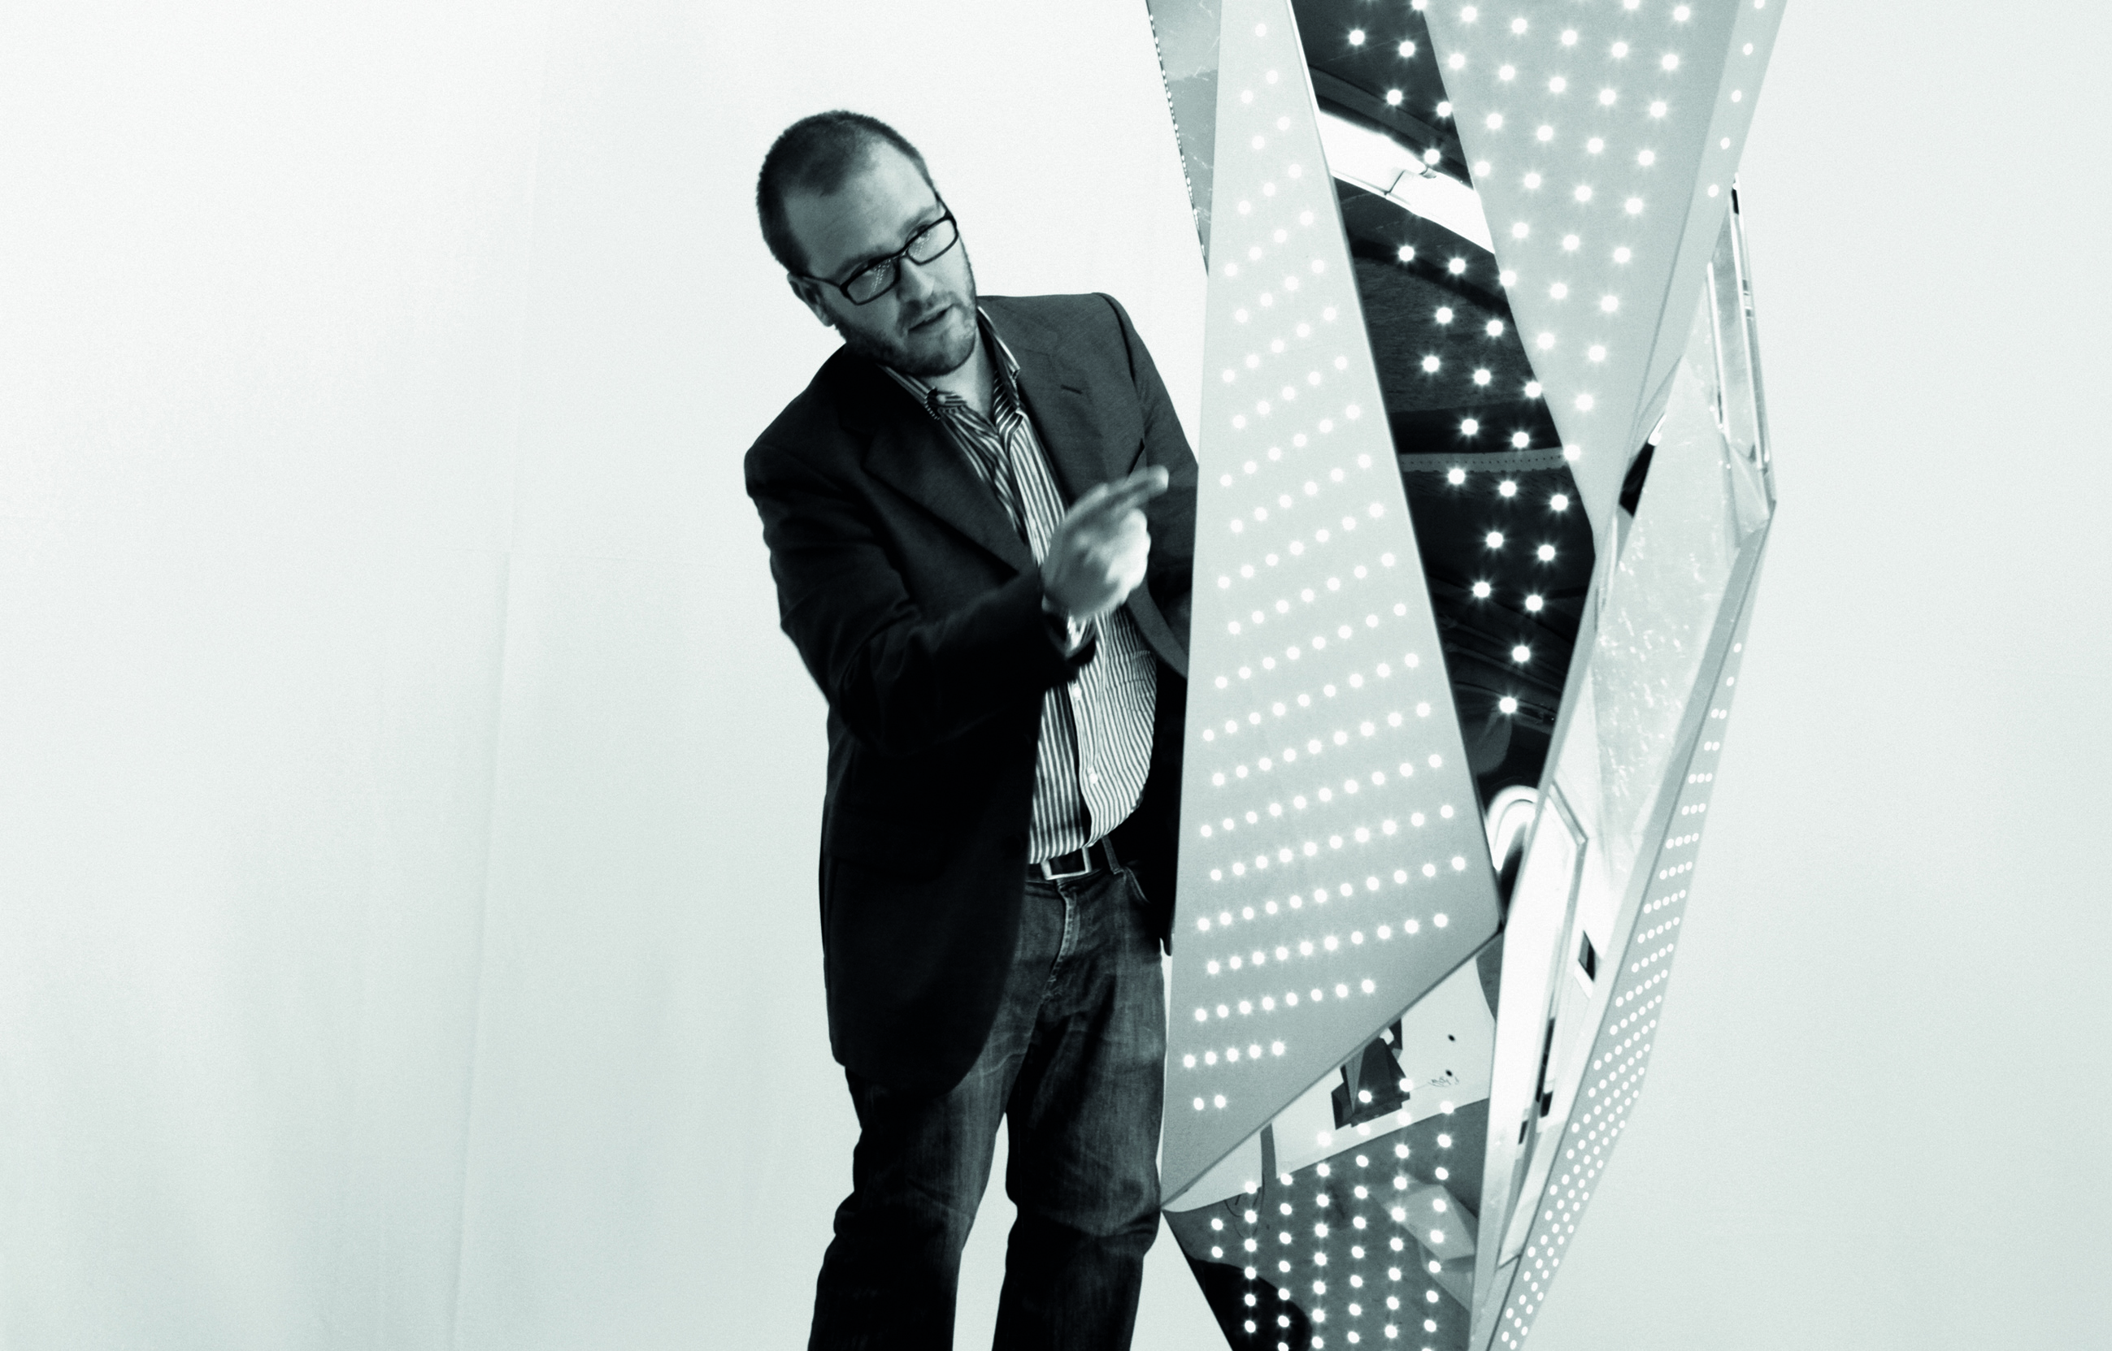
Noam Libeskind: We start from the assumption that the universe is some 14 billion years old. One way to visualise this, for example, is the idea that each second corresponds to one billion years, so that 14 seconds cover the entire history of the universe. You could, of course, also accelerate or slow down the sequence. The fact that we are thus able to control the speed with which the universe develops, gives you the freedom to do your own thinking about the phenomenon. If you switch on eL and watch the light move along the time loop, you emulate 14 billion years of cosmic history. This makes eL an object which allows us to think about the origins of the universe and of life and about how we have managed to get from the Big Bang to the complex world of today.

Daniel Libeskind: That's how close we are to the origins of the universe.

In what way did your scientific background and your father's architectural knowledge influence the development of eL?
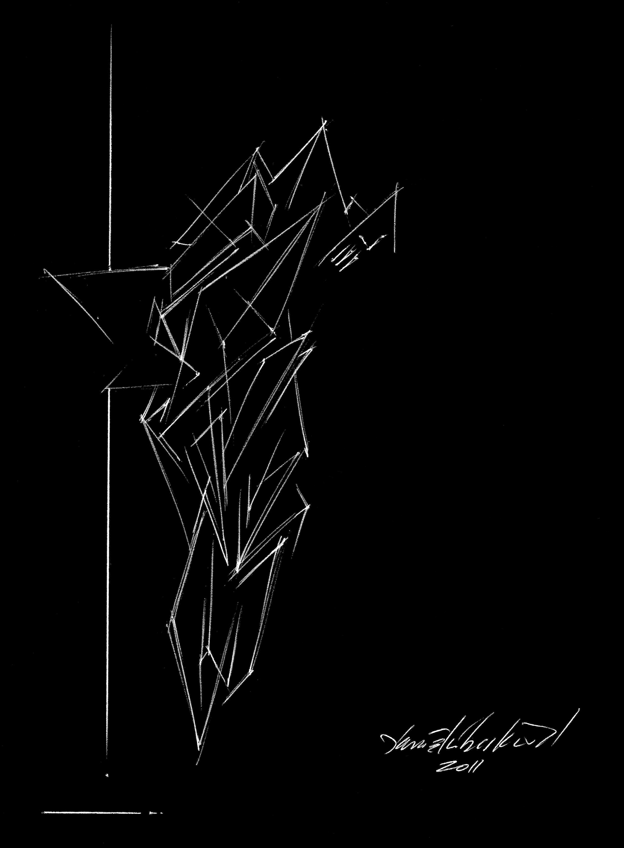
Noam Libeskind: So, with this Masterpiece, essentially we’re trying to tell the history of light. How light in the universe evolved, how it was created, how it is absorbed and re-emitted and how, over 14 billion years, the light in the entire universe was changing and was in turn affecting the evolution of the universe. We shaped a box representing a section of the universe, millions of light-years across, and out of that box we took little portions and used LEDs on the luminaire for each of those portions. Each LED stands for a small piece of the universe – although actually, it’s not so small, it could represent hundreds of thousands of light-years. It’s only small compared to the entire universe. So we have a large section of the universe and each small part of it is represented by one of the LEDs. The colour of the LEDs reflects the starlight in that particular part of the universe. When the LEDs are very bright it means there is a lot of starlight – a lot of bright lights going off. When the LEDs have a darker shade, it means that there is less starlight emerging from this particular part of the universe.

Daniel Libeskind: Today we are still at very close range to the beginnings of light, and it’s fascinating to consider how all the subatomic particles were formed, how they are a part of life, part of our own human experience.

Zumtobel. The Light.

Brief profile
The Zumtobel brand is a leading international supplier of integral lighting solutions that enable people to experience the interplay of light and architecture. As a leader in innovation, the luminaire manufacturer provides a comprehensive range of high-quality luminaires and lighting management systems for the most varied application areas of professional interior lighting – including offices and educational facilities, retail and presentation, hotels and wellness, health and care, art and culture as well as industry and engineering. Zumtobel is a brand of the Zumtobel AG group with its head office in Dornbirn, Vorarlberg (Austria).

Captions:
Photo 1:
Zumtobel's eL Masterpiece
Photo 2:
Architect Daniel Libeskind (c) Michael Klinkhamer Photography
Photo 3:
Astrophysicist Noam Libeskind
Photo 4:
Sketch of the eL Masterpiece

For more information, please contact:
Zumtobel Lighting GmbH
Nadja Frank
PR Manager
Schweizer Strasse 30
A-6851 Dornbirn
Tel. +43-5572-390-1303
Fax +43-5572-390-91303
E-mail: nadja.frank@zumtobel.com
www.zumtobel.com

