Press release

Highlight with a view of the sky
Lighting solution by Zumtobel for spectacular new trade fair building

The new building of Messe Basel is one of the most recent projects implemented by Herzog & de Meuron. The striking architecture fascinates trade fair visitors at first sight. The interior design is put in the right light using an efficient lighting solution by Zumtobel.

Dornbirn, July 2013 – The new hall complex of MCH Messe Basel opened its doors in April. Apart from the staggered hall structures arranged on top of each other, the new building designed by the renowned Basle architects' studio Herzog & de Meuron impresses on account of two other architectural features: on the one hand with a facade consisting of interweaving aluminium bands, on the other hand with the City Lounge - a covered square in the centre of the building with a spectacular opening allowing a view of the sky. A generously glazed ground floor provides for the transparency of the space, mitigating the bulky effect of the three-storey hall complex. The particular architectural virtues required a customised lighting concept that was developed by the renowned Bartenbach Lighting Laboratory. For the trade fair halls and the lobbies, the lighting designers have chosen a lighting solution by Zumtobel that scores high on account of its flexibility and energy efficiency. Thus, for the lighting of the lobbies, Zumtobel has developed a special-purpose luminaire that emphasises the architecture of the respective room to great effect. The LED light lines are installed in ceiling coves so that the indirect light follows the outlines of the room, creating a pleasant atmosphere. The light lines are fitted with warm or cool white LEDs. Moreover, RGB light lines are used for dynamic colour changes. In this way, a variety of lighting scenes can be created using a lighting management system.

Efficient lighting of the halls
The companies exhibiting their products in the complex of trade fair halls are provided with an area of approx. 38,000 square metres. Zumtobel has equipped this area, too, with a sustainable lighting solution. For perfect lighting of the retail and presentation halls, as well as in the warehouse, the flexible Tecton continuous-row lighting system is used with fluorescent lamps. Tecton is a continuous-row lighting system integrating a batten luminaire, lamps and a reflector within its trunking. This allows for easy mounting and reduces installation and maintenance costs. All functions such as power supply, lighting control and connection to the emergency lighting system can be integrated into the trunking thanks to a built-in current conducting section. In the area of the escalators, the hall lighting is complemented by the Panos Infinity LED downlight range, which boasts excellent lighting quality and particularly high efficiency. Zumtobel has additionally fitted the trade fair halls with the Puresign and Resclite LED luminaires combined with compact fluorescent lamps for emergencies.

Facts & figures
TECTON  http://www.zumtobel.com/tecton | Continuous-row lighting system with trunking that integrates power supply, lighting control and connection to emergency lighting; four different optics; perfect light direction; optionally available with daylight-based control, presence detection or motion sensor
PANOS INIFINITY LED  http://www.zumtobel.com/panos_infinity | LED downlight range; dimmable; colour temperature 3000 or 4000 K; high colour rendering Ra > 90; luminaire efficiency > 84 lm/W; symmetrical beam pattern
RESCLITE LED  http://www.zumtobel.com/resclite | LED emergency luminaire for escape routes; installed load of only 5 W; high IP rating: IP65 or IP40; power supply either centrally or with battery;
PURESIGN LED  http://www.zumtobel.com/puresign | LED escape sign luminaire ; width: 20 mm; aluminium design frame; installed load: 4.5 W; LED ERI spots and adjustable lenses; recessed into walls, ceilings; surface mounting with cord and as a remote box version; recognition range: 30 m

Captions:

(Photo credits: Iwan Baan)

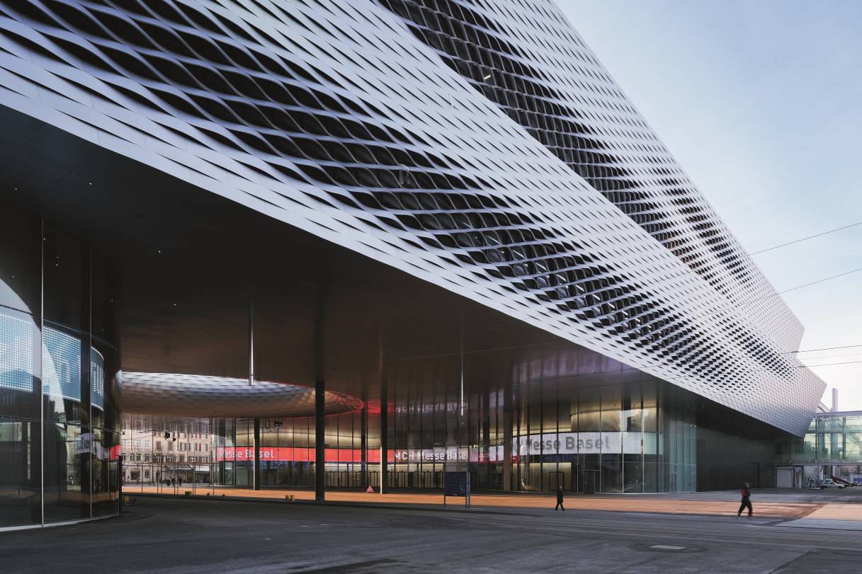

Caption 1: Above the glazed ground floor of the new trade fair building two further hall structures stand up, featuring an impressive facade consisting of interweaving aluminium bands.

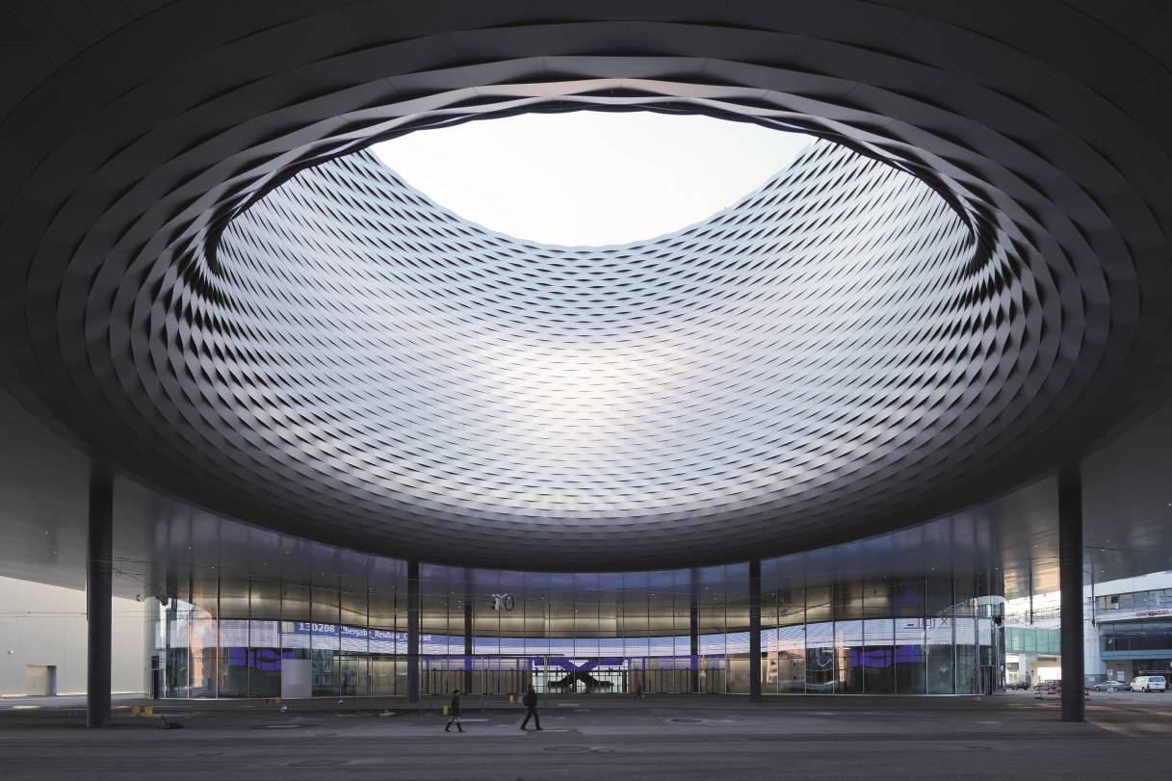
Caption 2: The spectacular atrium within the new trade fair building is another architectural highlight and attracts many visitors.

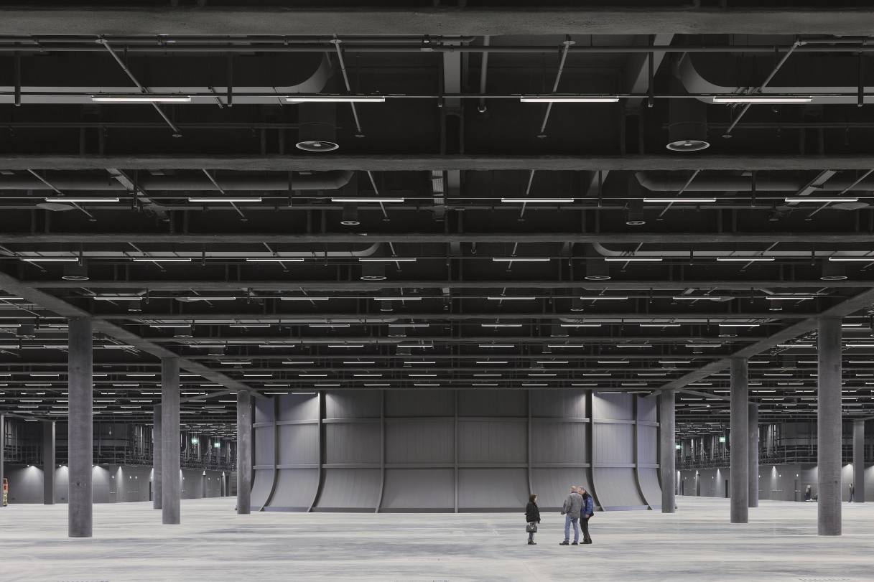
Caption 3: Perfect lighting for exhibitors: the trade fair halls were fitted with the effective Tecton continuous-row lighting system by Zumtobel.

Brief profile
Zumtobel is a leading international supplier of integral lighting solutions that enable people to experience the interplay of light and architecture. As a leader in innovation, the luminaire manufacturer provides a comprehensive range of high-quality luminaires and lighting management systems for the most varied application areas of professional interior lighting – including offices and educational facilities, presentation and retail, hotels and wellness, health and care, art and culture as well as industry and engineering. Zumtobel is a brand of the Zumtobel group with its head office in Dornbirn, Vorarlberg (Austria).

