Press release
Dornbirn, January 2012

Unique shopping experience
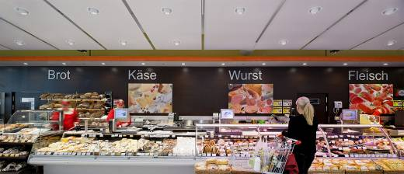
Zumtobel develops lighting solutions for high-quality presentation of goods
Shopping is nowadays imbued with a high degree of leisure-time character. People's willingness to consume is combined with an entertainment factor of increasing importance. Shopping centres and stores find themselves constrained to meet consumers' needs and present themselves and their products in the most appealing manner. In order to achieve this, brands and messages must be communicated in an authentic way, for the customers' behaviour is significantly influenced by their perception and sense of well-being. In this respect, illumination has an important task to fulfil.

Light conveys emotions, provides guidance to consumers and triggers impulses to buy. Furthermore, light has an influence on perceptible product qualities such as size, colour and material. Four specific parameters are, above all, essential for the design and implementation of integral lighting solutions: setting the stage, authenticity, naturalness and sustainability; they provide added value for presentation and retail in the long term. For Zumtobel, it is a matter of course to develop lighting solutions for the most varied application areas, always in the most efficient way, without, however, neglecting marketing requirements. Therefore, professional lighting means developing efficient and energy-saving lighting concepts which also meet the needs of presentation and retail targets. Zumtobel creates a balance between these different factors.

LEDs provide a unique design ambience
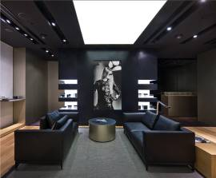
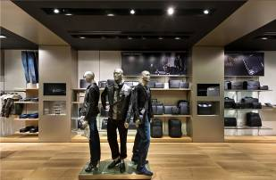
Shopping as a leisure-time activity – this particularly applies to the Asian megacity of Singapore. The shopping centre “The Shoppes at Marina Bay Sands” includes the 160 square metre Porsche Design Store offering a highly varied product range which needs to be presented in the best light – as well as the shop itself. The lighting atmosphere created by the innovative Discus LED spotlight meets the high demands of Porsche Design, skilfully highlighting the exquisite products. The Porsche Design philosophy is reflected in the shop fittings and can thus also be felt by the customers. A harmonious balance is created between materials, colours and light to achieve the desired effect. Especially in the premium range, the lighting system is required to stay discreetly in the background, nevertheless performing its task perfectly. Thanks to its low-profile design and unobtrusive formal language, the Discus product range based on LED technology blends into the interior without interfering with the overall impression. Only 28 mm wide, the spotlights made of die-cast aluminium are the ideal choice for the purist Porsche Design shop. The rotating and swivelling luminaires allow flexible adjustment to changing product displays, while the same level of lighting quality is maintained. The LEDs' luminous flux can be compared with that of a 20 W HIT or 90 W halogen system, however with considerably higher economic efficiency and a longer service life. The light colour of the Discus spotlights is matched to their surroundings, creating special accents together with the natural wood tones on the walls and the floor. The interplay of light and shadow catches people's eyes and invites shoppers to stay.
Highlights for fashion by Zumtobel
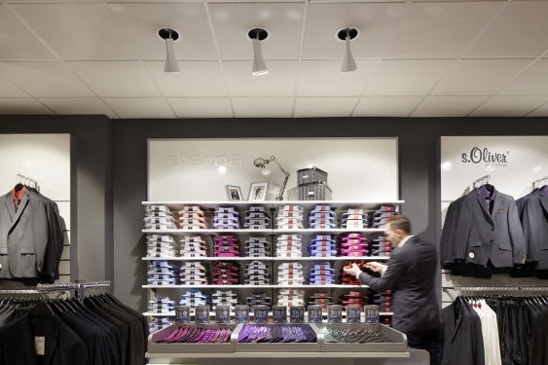
Thanks to state-of-the-art LED technology, the redesigned Vockeroth fashion store in Nordhausen is able to provide its customers with a new shopping experience. The owners wanted to impress their customers with comfort and a both authentic and exciting presentation of goods, while at the same time reducing energy consumption. Visitors are warmly welcomed by inviting ambient lighting provided by large circular luminaires built into the ceiling, which also bathe the POS terminals in soft light. In combination with LED spotlights, the lighting composition is full of contrasts and extends into the depth of the store, providing orientation for the eyes of the customers. The Iyon LED spotlight range and the Cardan LED lighting system provide accent lighting for the goods on display, ensuring a natural look of the various colours and materials, thanks to their excellent colour rendering of Ra > 90. Due to the LED luminaires' long service life of 50,000 hours, the Zumtobel lighting concept makes sure energy consumption is reduced despite maintaining equivalent lighting quality. Thus, 25% of the energy costs can be saved, compared with conventional lamps.
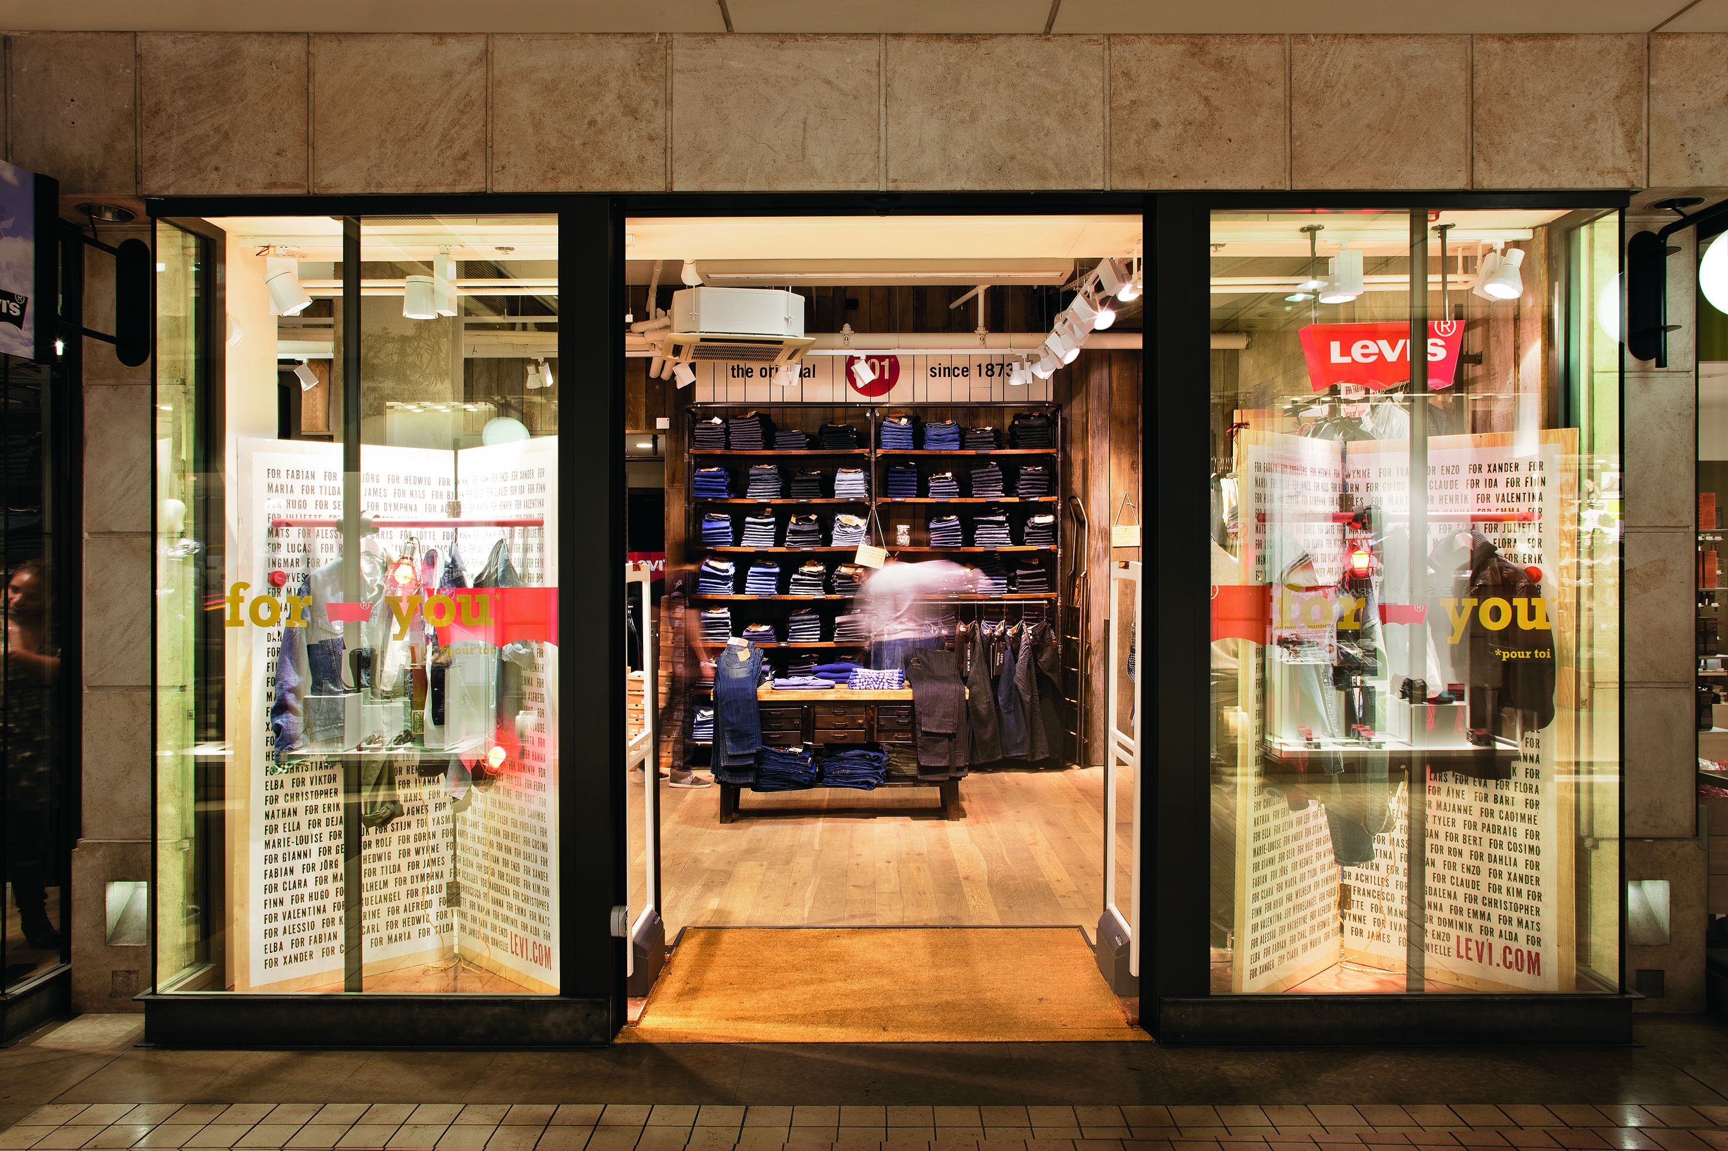
Reduced energy consumption is also a priority at Levi's LEED-certified Green Store in Paris. With sustainable fittings and Zumtobel's environmentally compatible lighting concept, the Californian jeans brand consistently pursues its idea of optimising its eco-balance. Besides opting for a minimalist interior, the designer team deliberately refrained from suspending the ceiling, so that the cables and suspension fittings of the luminaires remain visible design elements. Rotating and swivelling spotlights can easily be adjusted to match changing collections. The lighting system mainly based on LEDs has a long service life, resulting in reduced energy consumption of the shop. A daylight sensor makes sure a minimum of energy is consumed, ensuring that the various jeans models are presented to optimum effect, yet with economic efficiency, depending on sunlight and weather conditions. The daylight is supplemented by square LED fields of light which provide pleasant ambient lighting. Built-in presence detectors in the changing rooms reduce energy consumption even further. Levi’s first Green Store in Münster was soon able to reduce its energy consumption by 33%.

Energy efficiency award
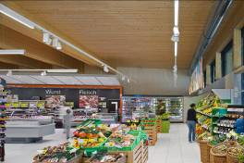
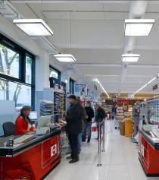
The requirements for the lighting concept of the Austrian SPAR climate-protection supermarkets were especially high. The supermarkets' CO₂ footprint should be kept as “green” as possible. In addition to architecture, construction and furnishings, the lighting solution, too, was supposed to provide utmost energy efficiency. The economically efficient lighting must, however, not ignore the customers' needs. For the three supermarkets in Vienna and Murau, Austria, as well as in Wetzikon, Switzerland, Zumtobel developed a consistent lighting concept based on LED. In addition to its high efficiency, the LED concept boasts excellent lighting quality and provides gentle and pleasant illumination for the products and customers: “Zumtobel’s innovative lighting solution covers all aspects required for an attractive retail space: optimum lighting for our customers as well as maximum energy savings for increased climate and environmental protection”, outlines Gerald Geiger, Head of Construction/Energy/Engineering, from the SPAR headquarters in Salzburg. The figures speak for themselves: in combination with other state-of-the-art structural measures, the branches save 50% of energy and up to 80 tonnes of CO₂. This could not fail to impress the Austrian Association for Sustainable Real-Estate Management (ÖGNI), which awarded the internationally renowned ÖGNI Gold certification to the climate-protection supermarket in Vienna. For the SPAR concept, the Tecton continuous-row lighting system used for ambient lighting was fitted with LEDs for the first time, thus combining high lighting quality with a long service life and low maintenance effort. Uniform and efficient LED ambient lighting without IR or UV radiation is particularly gentle on foodstuffs. The multi-functional trunking of the Tecton system can also be fitted with LED spotlights to highlight individual shelves and products without disturbing the uniform appearance.

Scintillating effects at Swarovski
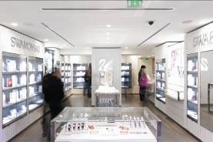
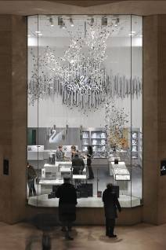
The Swarovski image is characterised by high precision and elegance. This had to be taken into account when developing a shop lighting concept for the branches in Paris. The lighting concepts for the locations at the Carrousel Louvre Gallery and on Champs Èlysées are the first two examples of a consistent lighting concept of the brand that is to be introduced world-wide. The integral lighting solution is consistently oriented towards a brand identity that can easily be perceived by the customer at an international level. The light creates unique reflections from the shiny cut crystals. 2Light Mini downlights by Zumtobel incorporated into the ceiling provide for high-quality ambient lighting, and can be adjusted to changing presentations and architectural or functional requirements, thanks to their gimbal-mounted, pivoting lighting heads that can be freely moved. The HIT lamp technology used ensures excellent colour rendering of the top-rate crystals and jewellery items. The delicate crystal element called “Chrysalis”, which is more than five metres high, is illuminated to great effect by two spotlight systems mounted on the same 3-phase track sections. Control via the Luxmate Emotion lighting management system allows intuitive adjustment of the LED spotlights' brightness and a variety of colours. Dynamically changing light colours provide effective visualisation of the crystals' multi-coloured reflections in the space. The elegant look characterised by straight-line architecture and high-quality products is supplemented by unobtrusive yet highly efficient LED emergency lighting.

4000 m² lighting concept at the Ušće Shopping Centre
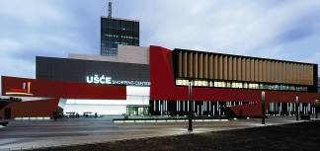
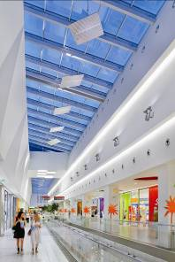
More than 140 shops of renowned international brands, a number of cafés and restaurants, a multiplex cinema, ninepins alleys and gambling halls, as well as a supermarket with a floor space of 4000 m²: this is currently Serbia's largest shopping centre. Architects from the renowned Chapman Taylor studio created an urban sculpture that is more than just a shopping centre. The combination of impressive architecture and superlative shopping relies on sharp contrasts. The signal-red façade attracts attention. The neutral interior design with white elements provides a calm background for the individual stores. The lighting design is in line with this concept of contrasts. As a contrast to the red façade, Zumtobel developed a design concept for the interior in collaboration with the lighting designers from Milan-based Voltaire Light Design. The atriums above the galleries allow plenty of daylight to enter. In the evening, daylight is replaced by soft lighting provided by Xeno spotlights and Miros projectors/mirrors. Thanks to numerous recesses, protrusions and suspended ceilings, where continuous-row lighting systems alternately produce calm or lively atmospheres, there is sufficient room for luminaires to be mounted. With the help of luminous ceilings, the central areas and the main entrance zone are bathed in warm and bright light. Deliberately placed, built-in downlights highlight selected surfaces with accent lighting and provide orientation for shoppers. All luminaires are controlled and dimmed via the Luxmate lighting management system.
To architect Gerardo Sannella it was important to create a harmonious and integrated whole: “The perfect implementation of light in architecture is achieved if the light can be felt instead of seen. To make artificial light appear like natural light – that is true art.”

Zumtobel. The Light.

Fact box: SPAR supermarket, Murau/AT
SPAR supermarket, Vienna/AT
SPAR supermarket, Wetzikon/CH
Architects: VeiderRöthlKaltenbrunner, Leoben/AT
3D, Design.Development-Display, Vienna/A
Rudolph Architekten, Zurich/CH
Lighting solution: Zumtobel – TECTON LED continuous-row lighting system, SL 1000 LED spotlights, SL 1000 semi-recessed LED downlights, CAREENA LED surface-mounted luminaires, CRAYON LED downlights, Resclite LED emergency luminaires, PANOS Infinity LED downlights, TUBILUX LED tubular luminaires, 2LIGHT Mini LED downlights, HEDERA LED luminaires
Zumtobel – TECTON LED continuous-row lighting system, SL 1000 LED spotlights, SL 1000 semi-recessed LED downlights, CAREENA LED surface-mounted luminaires, CRAYON LED downlights, Resclite LED emergency luminaires, PANOS Infinity LED downlights, TUBILUX LED tubular luminaires, 2LIGHT Mini LED downlights
Zumtobel – TECTON LED continuous-row lighting system, SL 1000 LED spotlights, SL 1000 semi-recessed LED downlights, CAREENA LED surface-mounted luminaires, CRAYON LED downlights, Resclite LED emergency luminaires, PANOS Infinity LED downlights, TUBILUX LED tubular luminaires, VIVO LED pendant luminaires

Fact box: Porsche Design Store, Singapore
Architects: Porsche Design Studio and BlocherBlocher Partners
Lighting solution: Zumtobel – DISCUS LED spotlights

Fact box: Swarovski Galleries, Paris/F
Architects: Thomas Madoery, Swarovski Corporation AG, Zurich/CH
Lighting solution: Zumtobel – 2LIGHT C Mini downlights, VIVO spotlights, ARCOS LED spotlights, RESCLITE and ARTSIGN emergency luminaires; lighting management system: LUXMATE Emotion

Fact box: Levi’s Green Store, Paris/F
Architects: Levi’s In House Design Team
Lighting solution: Zumtobel – CAREENA recessed and surface-mounted LED luminaires, SUPERSYSTEM modular LED lighting system, LIVIANO spotlights, SL 1000 LED spotlights, LUXMATE Daylight lighting control system

Fact box: Vockeroth fashion store, Nordhausen/D
Architects: ./.
Lighting solution: Zumtobel – ONDARIA recessed luminaires, PANOS INFINITY LED downlights, IYON LED spotlights, RESCLITE emergency luminaires, COMSIGN escape sign luminaires

Fact box: Ušće Shopping Centre, Belgrade/SRB
Architects: Chapman Taylor ArchitettiS.r.l, Milan/I
Lighting solution: Slotlight II luminous ceilings and light lines, PANOS Q and PANOS M downlights, XENO spotlights and MIROS projectors/mirrors, TECTON Tetris continuous-row lighting system, RESCLITE and ONLITE SB 128 emergency luminaires, LUXMATE Professional lighting management system

Brief profile
The Zumtobel brand is a leading international supplier of integral lighting solutions that enable people to experience the interplay of light and architecture. As a leader in innovation, the luminaire manufacturer provides a comprehensive range of high-quality luminaires and lighting management systems for the most varied application areas of professional interior lighting – including offices and educational facilities, retail and presentation, hotels and wellness, health and care, art and culture as well as industry and engineering. Zumtobel is a brand of the Zumtobel AG group with its head office in Dornbirn, Vorarlberg (Austria).

Captions:

Caption 1: Fresh-product counters at the first SPAR climate-protection supermarket in Vienna:

SL 1000 semi-recessed LED downlights provide high-quality, gentle illumination of the goods on display

Caption 2: The minimalist design of the Discus LED spotlight perfectly matches the purist shop fitttings of Porsche Design

Caption 3: The LED spotlights perfectly blend into any architecture

Caption 4: Iyon LED spotlights provide accent lighting for the goods on display, directing shoppers' attention to them

Caption 5: Passers-by perceive Levi’s as a brand committed to patina. The interior design and the concept of the LEED-certified store are exemplary in terms of sustainability and ecology

Caption 6: The Tecton LED continuous-row lighting system and SL 1000 LED spotlights ensure a high level of lighting quality and attractive presentation of goods as well as low energy consumption

Caption 7: The cash point areas are properly illuminated by suspended Careena LED luminaires

Caption 8: The lighting concept of the Swarovski boutique on Champs Élysées is almost identical to that at the Carrousel Louvre Gallery

Caption 9: The large display window at the Carrousel Louvre attracts passers-by, who marvel at the Swarovski exhibits brilliantly sparkling in the light

Caption 10: Attention is drawn and curiosity is aroused by the new shopping centre's luminous red façade

Caption 11: In the store galleries, the incoming daylight is replaced in the evening by soft artificial lighting produced by Xeno spotlights and Miros projectors/mirrors; continuous-row lighting systems provide accent lighting

For more information, please contact:
Zumtobel Lighting GmbH
Nadja Frank
PR Manager
SchweizerStrasse 30
A-6851 Dornbirn

Tel. +43-5572-390-1303
Fax +43-5572-390-91303
nadja.frank@zumtobel.com
www.zumtobel.com
Publication of this document is free if due acknowledgement is made: Zumtobel

